UNITED STATES
SECURITIES AND EXCHANGE COMMISSION
WASHINGTON, D.C. 20549
FORM 8-K
CURRENT REPORT
Pursuant to Section 13 or 15(d) of the Securities Exchange Act of 1934
Date of Report (Date of earliest event reported): October 2, 2026
CERENOME, INC.
(Exact name of Registrant as Specified in Its Charter)
Delaware | 001-34375 | 33-0827593
(State or Other Jurisdiction  of Incorporation) | (Commission File Number) | (IRS Employer  Identification No.)
6420 Levit Green Boulevard  Suite 310  Houston, Texas |  | 77021
(Address of Principal Executive Offices) |  | (Zip Code)

Registrant’s Telephone Number, Including Area Code: (737) 255-7194

PLUS THERAPEUTICS, INC.
(Former Name or Former Address, if Changed Since Last Report)
Check the appropriate box below if the Form 8-K filing is intended to simultaneously satisfy the filing obligation of the registrant under any of the following provisions:

☐ | Written communications pursuant to Rule 425 under the Securities Act (17 CFR 230.425)
☐ | Soliciting material pursuant to Rule 14a-12 under the Exchange Act (17 CFR 240.14a-12)
☐ | Pre-commencement communications pursuant to Rule 14d-2(b) under the Exchange Act (17 CFR 240.14d-2(b))
☐ | Pre-commencement communications pursuant to Rule 13e-4(c) under the Exchange Act (17 CFR 240.13e-4(c))
Securities registered pursuant to Section 12(b) of the Act:

Title of each class |  | Trading  Symbol(s) |  | Name of each exchange on which registered
Common Stock, par value $0.001 |  | CNSY |  | The Nasdaq Capital Market
Indicate by check mark whether the registrant is an emerging growth company as defined in Rule 405 of the Securities Act of 1933 (§ 230.405 of this chapter) or Rule 12b-2 of the Securities Exchange Act of 1934 (§ 240.12b-2 of this chapter).
Emerging growth company ☐
If an emerging growth company, indicate by check mark if the registrant has elected not to use the extended transition period for complying with any new or revised financial accounting standards provided pursuant to Section 13(a) of the Exchange Act. ☐

Item 8.01. Other Events.

On September 30, 2026, Cerenome, Inc. updated its corporate presentation for use in meetings with investors, analysts and others. A copy of certain updated slides is filed as Exhibit 99.1 to this current report on Form 8-K and is incorporated herein by reference.
Item 9.01 Financial Statements and Exhibits.

Exhibit  Number |  | Description
99.1 |  | Investor Presentation as of September 30, 2026.
104 |  | Cover Page Interactive Data File (embedded within the Inline XBRL document)

1

SIGNATURES
Pursuant to the requirements of the Securities Exchange Act of 1934, the registrant has duly caused this report to be signed on its behalf by the undersigned hereunto duly authorized.

 |  | CERENOME, INC.
Date: October 2, 2026 |  | By: | /s/ Marc H. Hedrick, M.D.
 |  |  | Name: Marc H. Hedrick, M.D.
 |  |  | Title: President and Chief Executive Officer

2

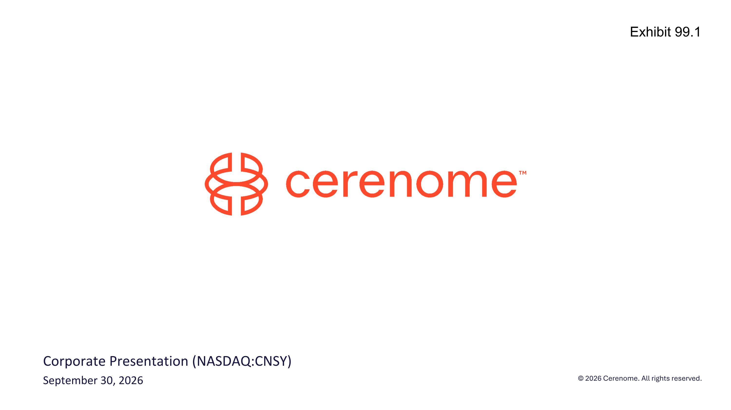
Corporate Presentation (NASDAQ:CNSY) September 30, 2026 Exhibit 99.1

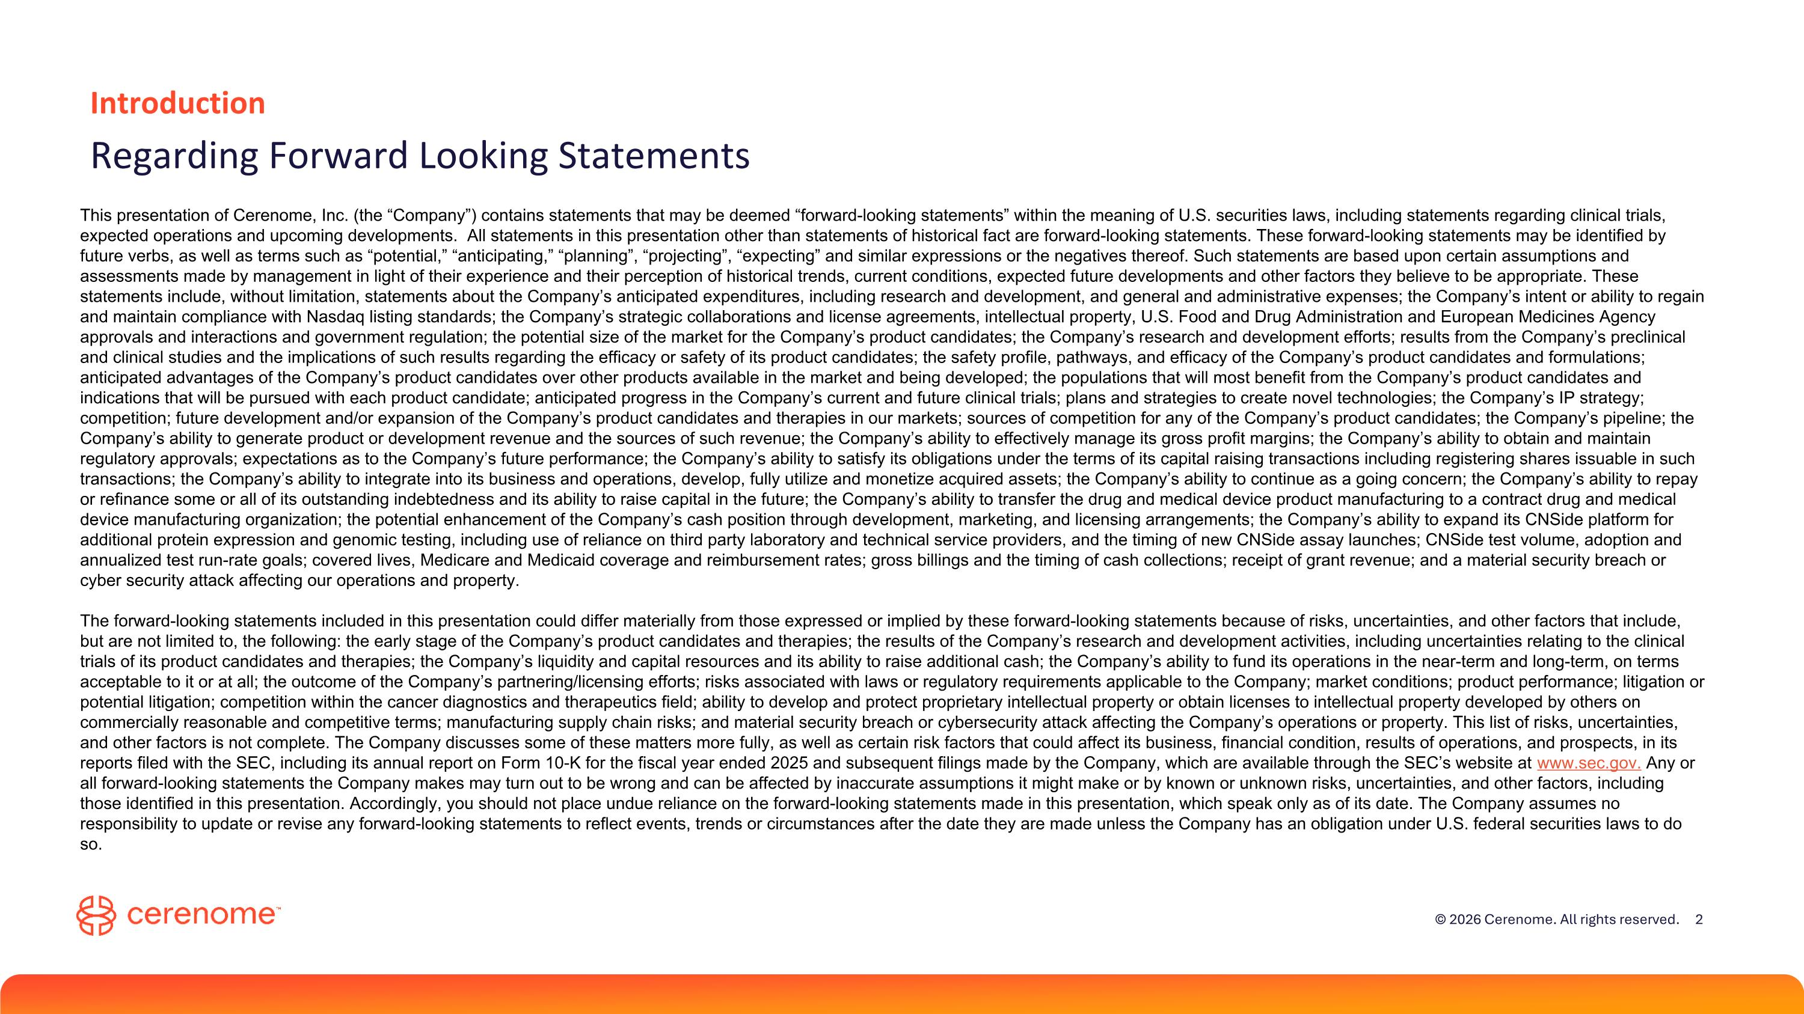
Introduction Regarding Forward Looking Statements This presentation of Cerenome, Inc. (the “Company”) contains statements that may be deemed “forward-looking statements” within the meaning of U.S. securities laws, including statements regarding clinical trials, expected operations and upcoming developments. All statements in this presentation other than statements of historical fact are forward-looking statements. These forward-looking statements may be identified by future verbs, as well as terms such as “potential,” “anticipating,” “planning”, “projecting”, “expecting” and similar expressions or the negatives thereof. Such statements are based upon certain assumptions and assessments made by management in light of their experience and their perception of historical trends, current conditions, expected future developments and other factors they believe to be appropriate. These statements include, without limitation, statements about the Company’s anticipated expenditures, including research and development, and general and administrative expenses; the Company’s intent or ability to regain and maintain compliance with Nasdaq listing standards; the Company’s strategic collaborations and license agreements, intellectual property, U.S. Food and Drug Administration and European Medicines Agency approvals and interactions and government regulation; the potential size of the market for the Company’s product candidates; the Company’s research and development efforts; results from the Company’s preclinical and clinical studies and the implications of such results regarding the efficacy or safety of its product candidates; the safety profile, pathways, and efficacy of the Company’s product candidates and formulations; anticipated advantages of the Company’s product candidates over other products available in the market and being developed; the populations that will most benefit from the Company’s product candidates and indications that will be pursued with each product candidate; anticipated progress in the Company’s current and future clinical trials; plans and strategies to create novel technologies; the Company’s IP strategy; competition; future development and/or expansion of the Company’s product candidates and therapies in our markets; sources of competition for any of the Company’s product candidates; the Company’s pipeline; the Company’s ability to generate product or development revenue and the sources of such revenue; the Company’s ability to effectively manage its gross profit margins; the Company’s ability to obtain and maintain regulatory approvals; expectations as to the Company’s future performance; the Company’s ability to satisfy its obligations under the terms of its capital raising transactions including registering shares issuable in such transactions; the Company’s ability to integrate into its business and operations, develop, fully utilize and monetize acquired assets; the Company’s ability to continue as a going concern; the Company’s ability to repay or refinance some or all of its outstanding indebtedness and its ability to raise capital in the future; the Company’s ability to transfer the drug and medical device product manufacturing to a contract drug and medical device manufacturing organization; the potential enhancement of the Company’s cash position through development, marketing, and licensing arrangements; the Company’s ability to expand its CNSide platform for additional protein expression and genomic testing, including use of reliance on third party laboratory and technical service providers, and the timing of new CNSide assay launches; CNSide test volume, adoption and annualized test run-rate goals; covered lives, Medicare and Medicaid coverage and reimbursement rates; gross billings and the timing of cash collections; receipt of grant revenue; and a material security breach or cyber security attack affecting our operations and property. The forward-looking statements included in this presentation could differ materially from those expressed or implied by these forward-looking statements because of risks, uncertainties, and other factors that include, but are not limited to, the following: the early stage of the Company’s product candidates and therapies; the results of the Company’s research and development activities, including uncertainties relating to the clinical trials of its product candidates and therapies; the Company’s liquidity and capital resources and its ability to raise additional cash; the Company’s ability to fund its operations in the near-term and long-term, on terms acceptable to it or at all; the outcome of the Company’s partnering/licensing efforts; risks associated with laws or regulatory requirements applicable to the Company; market conditions; product performance; litigation or potential litigation; competition within the cancer diagnostics and therapeutics field; ability to develop and protect proprietary intellectual property or obtain licenses to intellectual property developed by others on commercially reasonable and competitive terms; manufacturing supply chain risks; and material security breach or cybersecurity attack affecting the Company’s operations or property. This list of risks, uncertainties, and other factors is not complete. The Company discusses some of these matters more fully, as well as certain risk factors that could affect its business, financial condition, results of operations, and prospects, in its reports filed with the SEC, including its annual report on Form 10-K for the fiscal year ended 2025 and subsequent filings made by the Company, which are available through the SEC’s website at www.sec.gov. Any or all forward-looking statements the Company makes may turn out to be wrong and can be affected by inaccurate assumptions it might make or by known or unknown risks, uncertainties, and other factors, including those identified in this presentation. Accordingly, you should not place undue reliance on the forward-looking statements made in this presentation, which speak only as of its date. The Company assumes no responsibility to update or revise any forward-looking statements to reflect events, trends or circumstances after the date they are made unless the Company has an obligation under U.S. federal securities laws to do so.

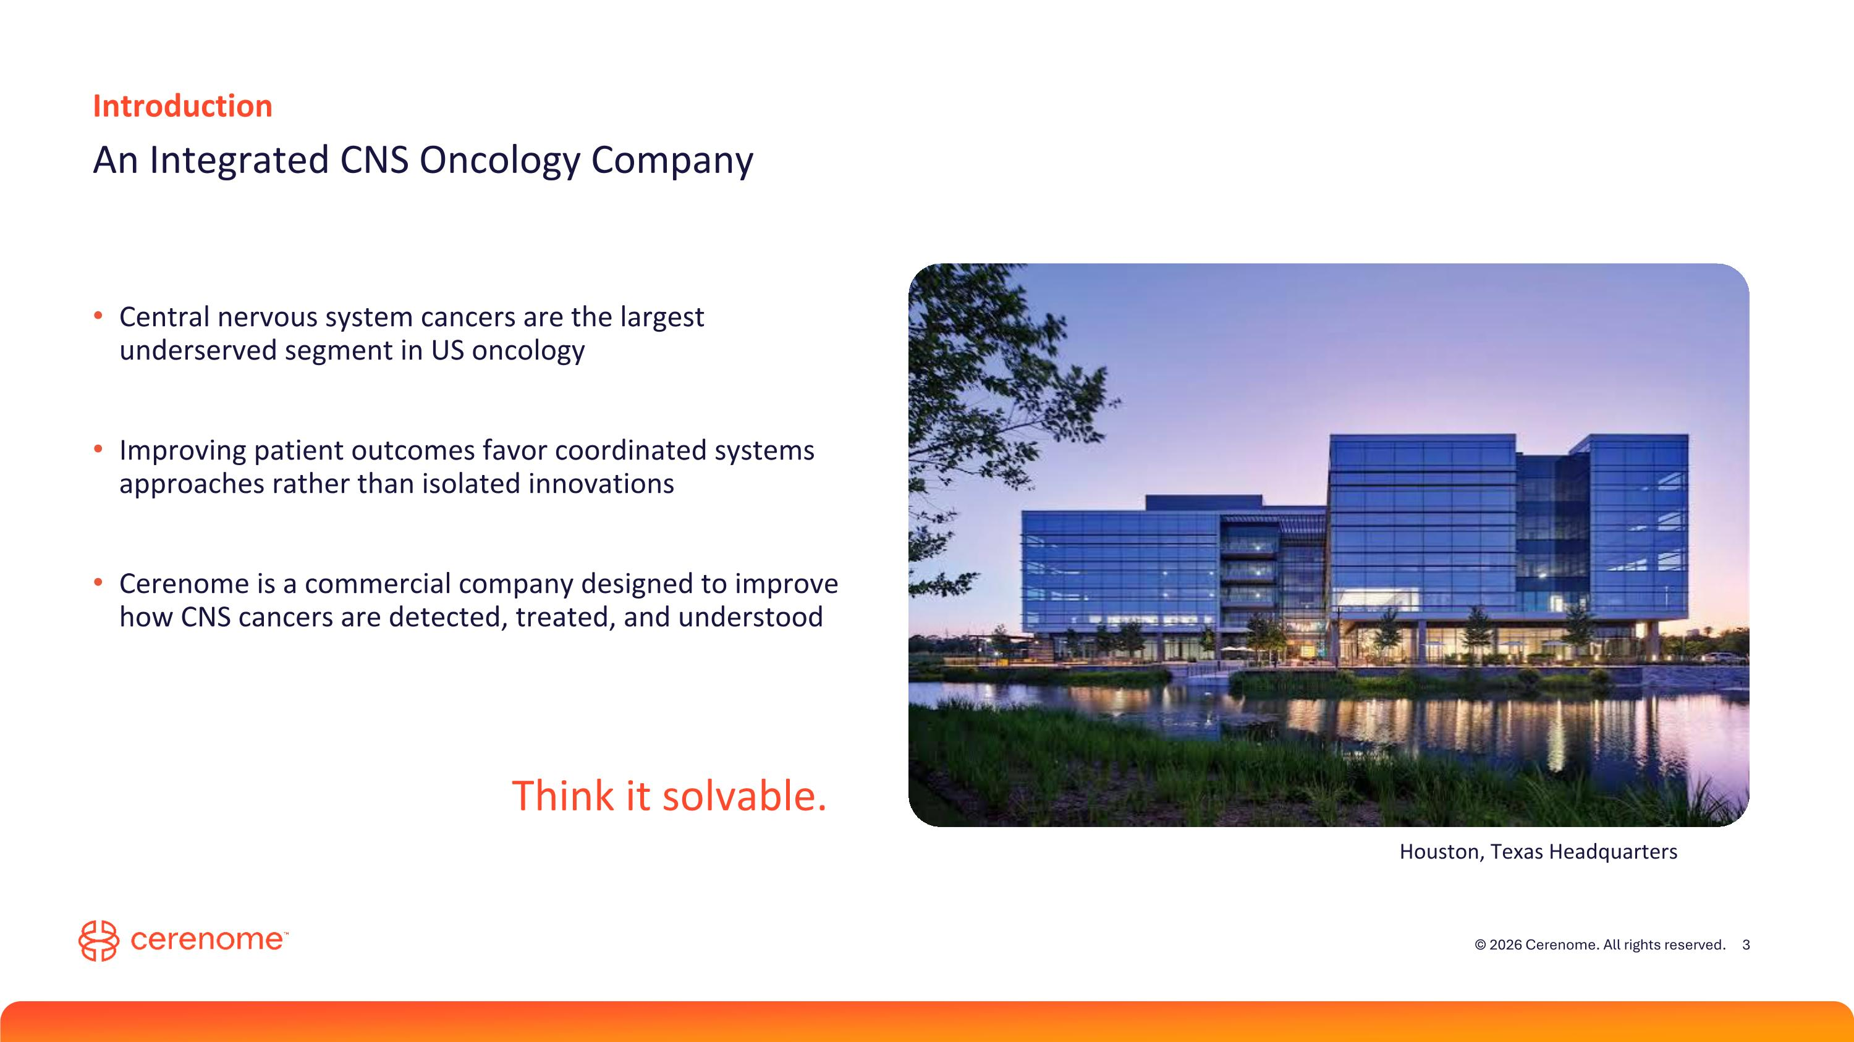
Houston, Texas Headquarters Introduction An Integrated CNS Oncology Company Central nervous system cancers are the largest underserved segment in US oncology Improving patient outcomes favor coordinated systems approaches rather than isolated innovations Cerenome is a commercial company designed to improve how CNS cancers are detected, treated, and understood Think it solvable.

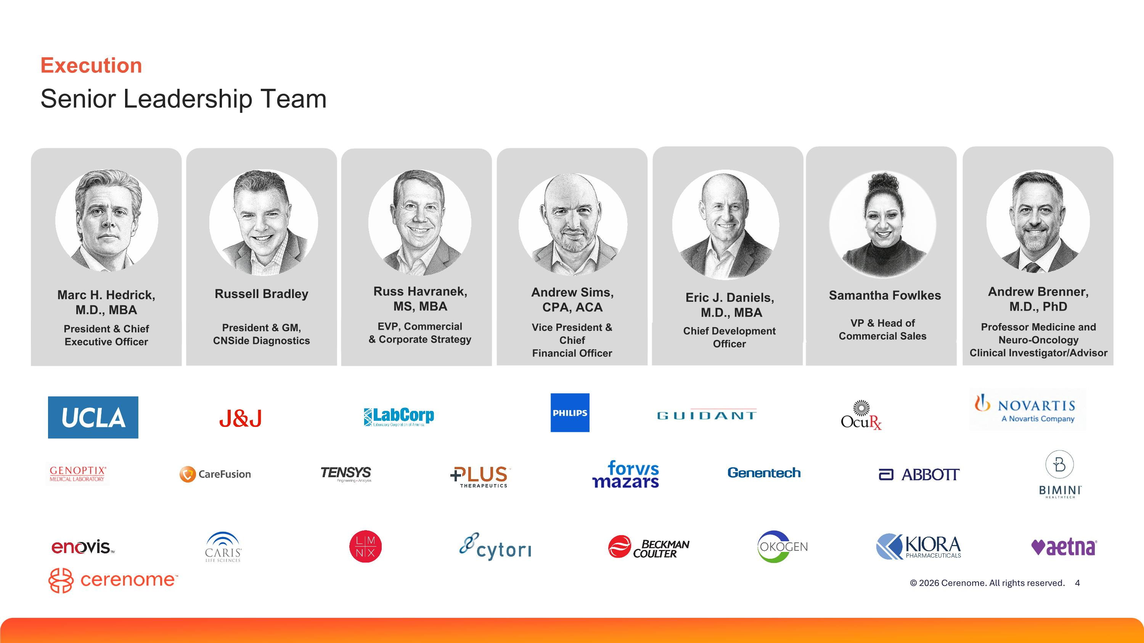
Execution Senior Leadership Team Marc H. Hedrick, M.D., MBA President & Chief Executive Officer Eric J. Daniels,? M.D., MBA Chief Development Officer Andrew Sims, ?CPA, ACA Vice President & Chief Financial Officer Russ Havranek, ?MS, MBA EVP, Commercial & Corporate Strategy Samantha Fowlkes VP & Head of Commercial Sales Russell Bradley President & GM, CNSide Diagnostics Andrew Brenner, M.D., PhD Professor Medicine and Neuro-Oncology Clinical Investigator/Advisor

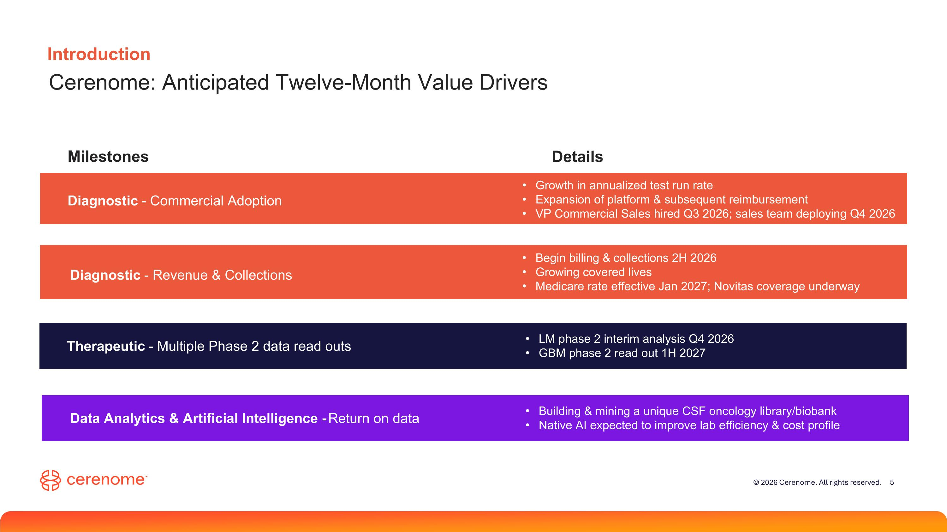
Diagnostic - Commercial Adoption Diagnostic - Revenue & Collections Therapeutic - Multiple Phase 2 data read outs Introduction Cerenome: Anticipated Twelve-Month Value Drivers Milestones Details Growth in annualized test run rate Expansion of platform & subsequent reimbursement VP Commercial Sales hired Q3 2026; sales team deploying Q4 2026 Begin billing & collections 2H 2026 Growing covered lives Medicare rate effective Jan 2027; Novitas coverage underway LM phase 2 interim analysis Q4 2026 GBM phase 2 read out 1H 2027 Data Analytics & Artificial Intelligence - Return on data Building & mining a unique CSF oncology library/biobank Native AI expected to improve lab efficiency & cost profile

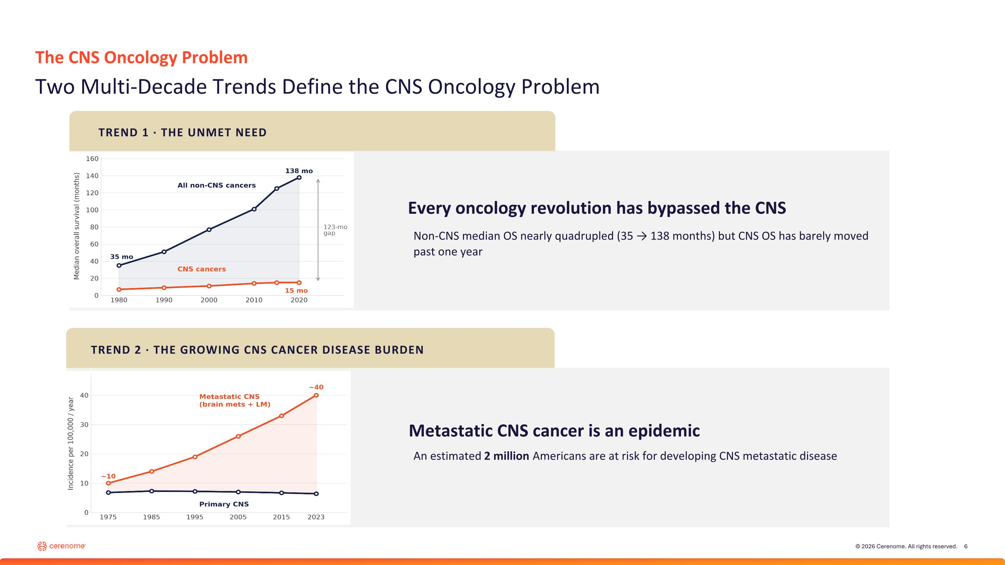
The CNS Oncology Problem Two Multi-Decade Trends Define the CNS Oncology Problem Every oncology revolution has bypassed the CNS TREND 1 · THE UNMET NEED TREND 2 · THE GROWING CNS CANCER DISEASE BURDEN Metastatic CNS cancer is an epidemic Non-CNS median OS nearly quadrupled (35 → 138 months) but CNS OS has barely moved past one year An estimated 2 million Americans are at risk for developing CNS metastatic disease

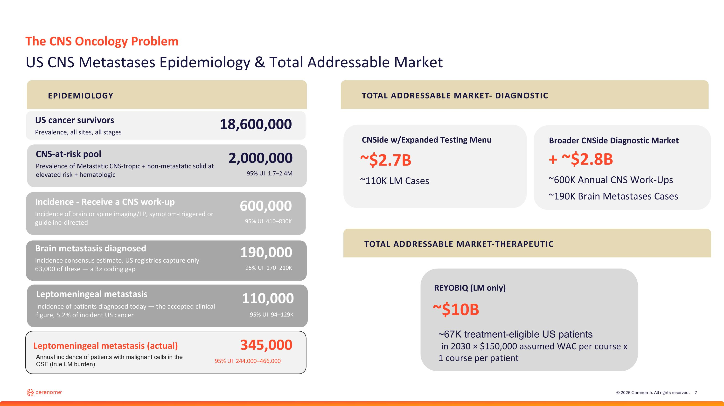
The CNS Oncology Problem US CNS Metastases Epidemiology & Total Addressable Market US cancer survivors Prevalence, all sites, all stages 18,600,000 CNS-at-risk pool Prevalence of Metastatic CNS-tropic + non-metastatic solid at elevated risk + hematologic 2,000,000 95% UI 1.7–2.4M Incidence - Receive a CNS work-up Incidence of brain or spine imaging/LP, symptom-triggered or guideline-directed 600,000 95% UI 410–830K Brain metastasis diagnosed Incidence consensus estimate. US registries capture only 63,000 of these — a 3× coding gap 190,000 95% UI 170–210K Leptomeningeal metastasis Incidence of patients diagnosed today — the accepted clinical figure, 5.2% of incident US cancer 110,000 95% UI 94–129K + ~$2.8B ~600K Annual CNS Work-Ups ~190K Brain Metastases Cases Broader CNSide Diagnostic Market ~$2.7B ~110K LM Cases CNSide w/Expanded Testing Menu ~$10B REYOBIQ (LM only) ~67K treatment-eligible US patients? in 2030 × $150,000 assumed WAC per course x 1 course per patient EPIDEMIOLOGY TOTAL ADDRESSABLE MARKET- DIAGNOSTIC TOTAL ADDRESSABLE MARKET-THERAPEUTIC Leptomeningeal metastasis (actual) 345,000 95% UI 244,000–466,000 Annual incidence of patients with malignant cells in the CSF (true LM burden)

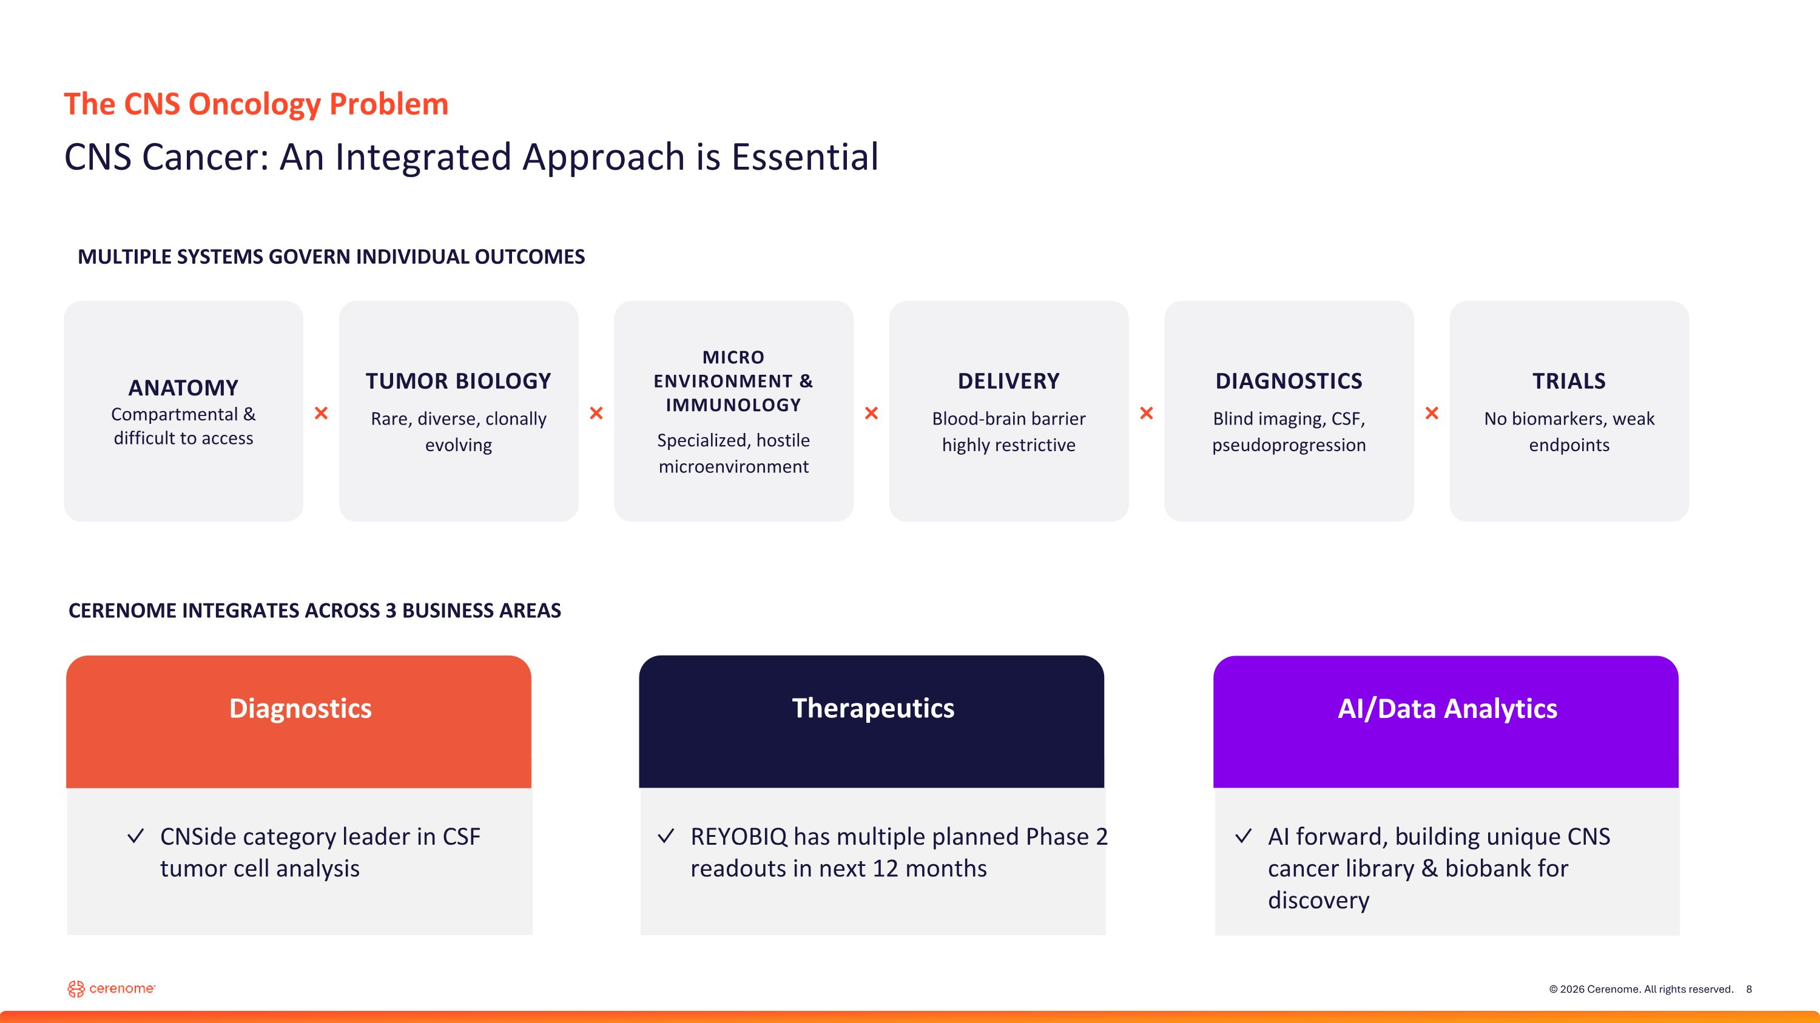
The CNS Oncology Problem CNS Cancer: An Integrated Approach is Essential ANATOMY Compartmental & difficult to access × TUMOR BIOLOGY Rare, diverse, clonally evolving × MICRO ENVIRONMENT & IMMUNOLOGY Specialized, hostile microenvironment × DELIVERY Blood-brain barrier highly restrictive × DIAGNOSTICS Blind imaging, CSF, pseudoprogression × TRIALS No biomarkers, weak endpoints CERENOME INTEGRATES ACROSS 3 BUSINESS AREAS Diagnostics CNSide category leader in CSF tumor cell analysis Therapeutics AI/Data Analytics REYOBIQ has multiple planned Phase 2 readouts in next 12 months AI forward, building unique CNS cancer library & biobank for discovery MULTIPLE SYSTEMS GOVERN INDIVIDUAL OUTCOMES


Assess Diagnostics

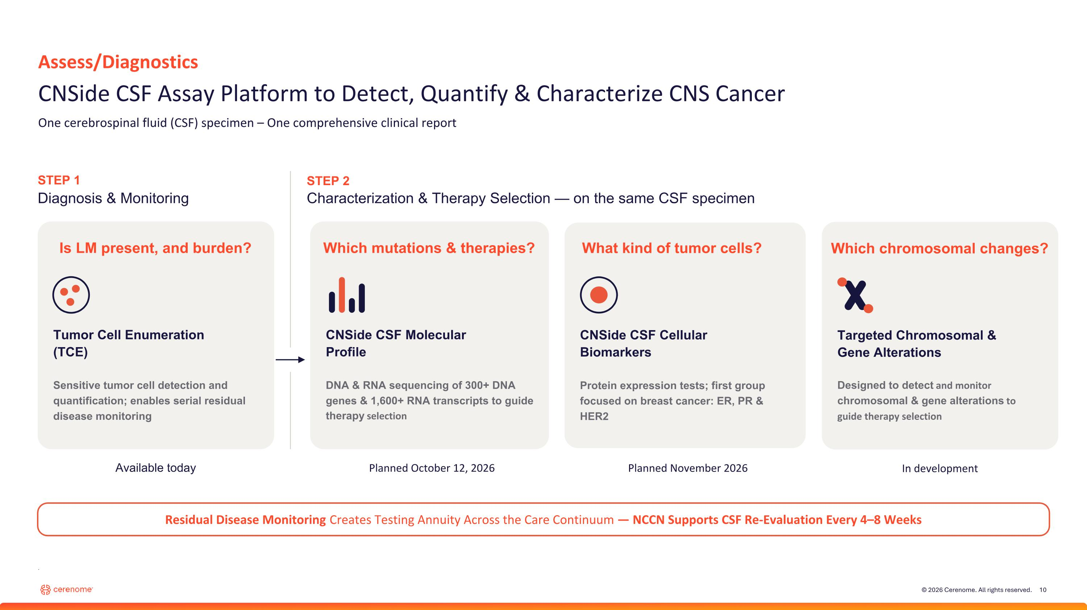
Assess/Diagnostics CNSide CSF Assay Platform to Detect, Quantify & Characterize CNS Cancer One cerebrospinal fluid (CSF) specimen – One comprehensive clinical report STEP 1 Diagnosis & Monitoring STEP 2 Characterization & Therapy Selection — on the same CSF specimen Tumor Cell Enumeration (TCE) Is LM present, and burden? Sensitive tumor cell detection and quantification; enables serial residual disease monitoring CNSide CSF Cellular Biomarkers What kind of tumor cells? Protein expression tests; first group focused on breast cancer: ER, PR & HER2 Targeted Chromosomal & Gene Alterations Which chromosomal changes? Designed to detect and monitor chromosomal & gene alterations to guide therapy selection CNSide CSF Molecular Profile Which mutations & therapies? DNA & RNA sequencing of 300+ DNA genes & 1,600+ RNA transcripts to guide therapy selection Residual Disease Monitoring Creates Testing Annuity Across the Care Continuum — NCCN Supports CSF Re-Evaluation Every 4–8 Weeks Available today Planned November 2026 In development Planned October 12, 2026 .

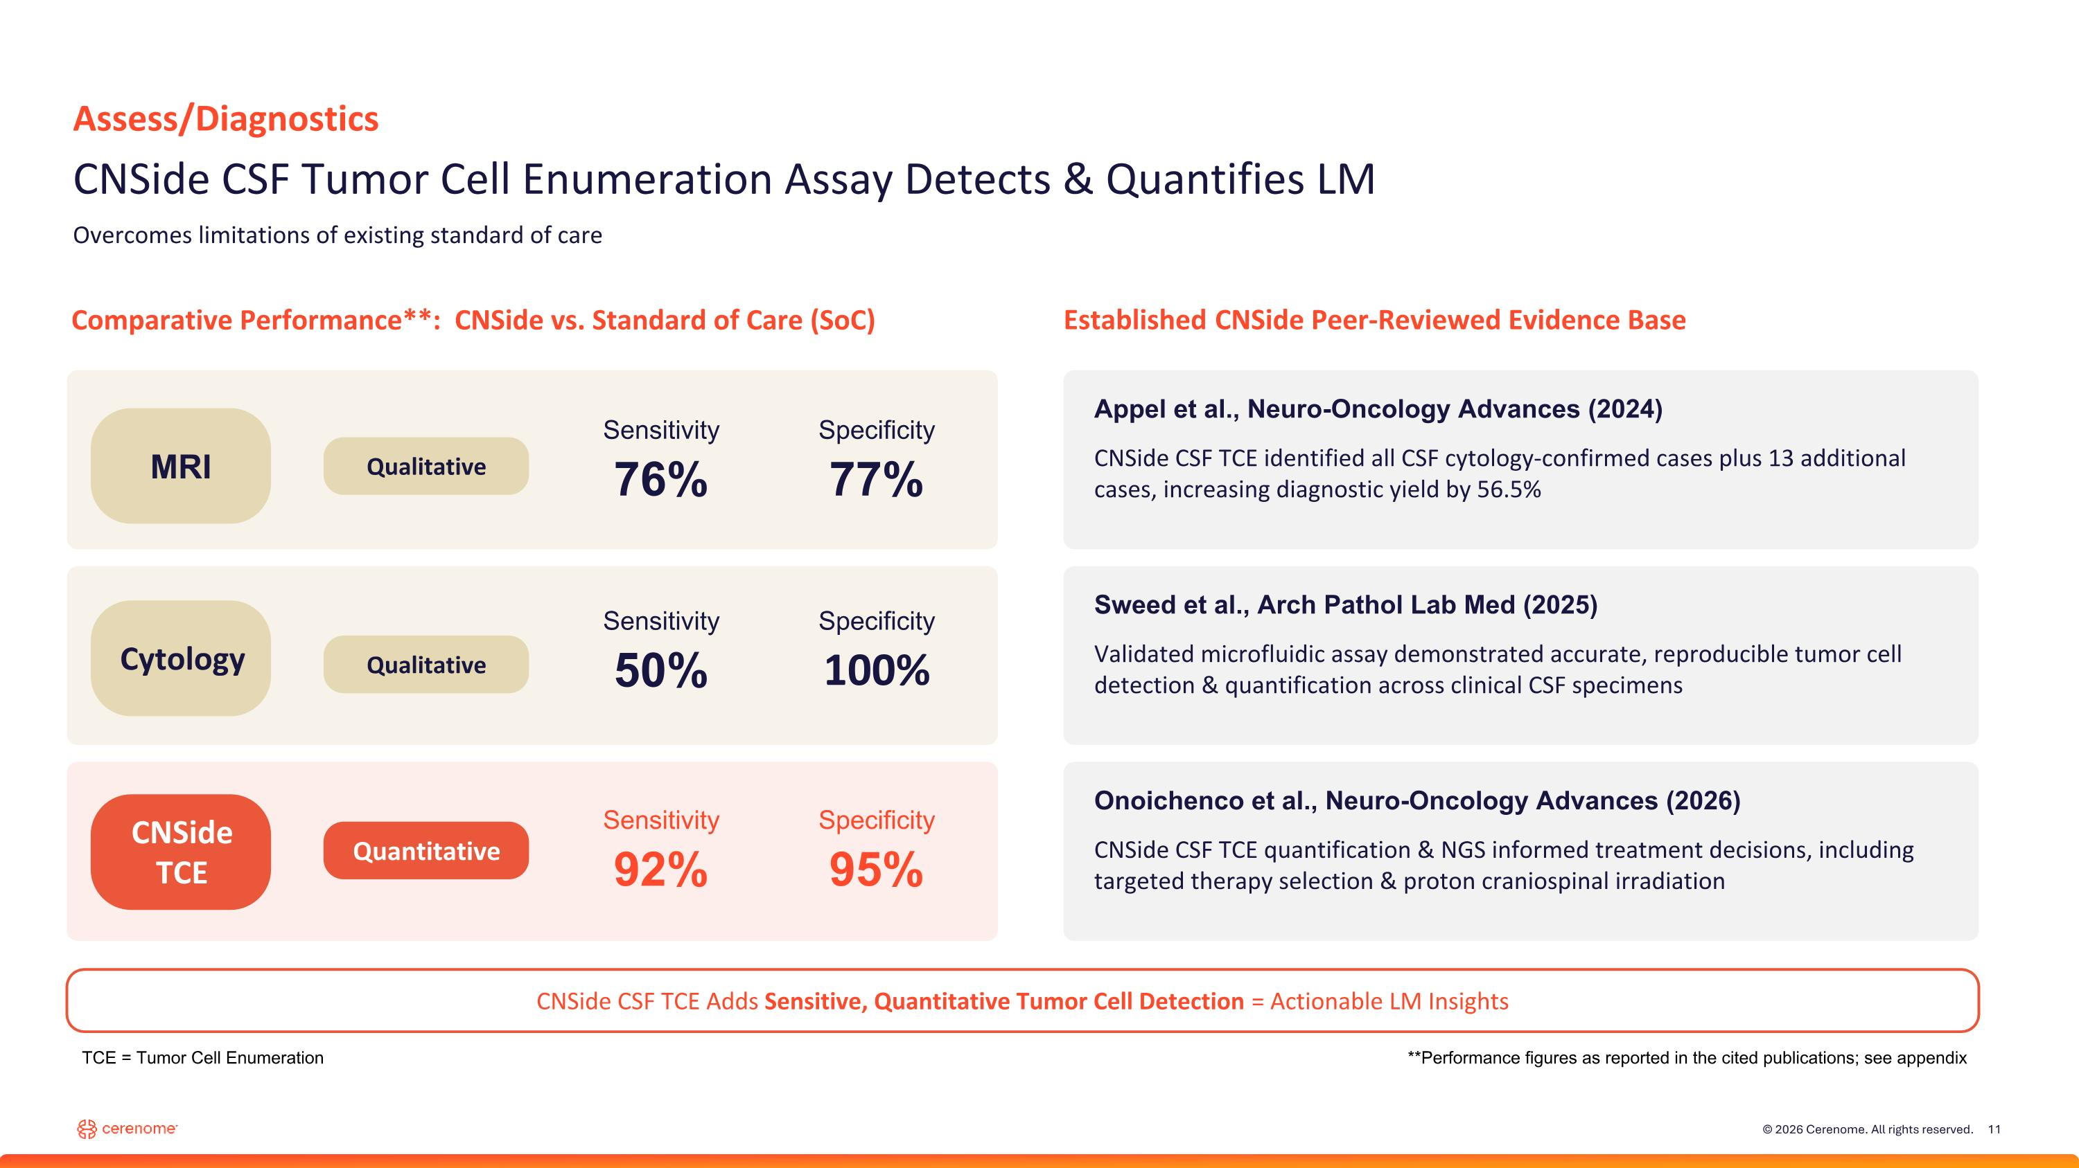
Comparative Performance**: CNSide vs. Standard of Care (SoC) Established CNSide Peer-Reviewed Evidence Base MRI Sensitivity 76% Specificity 77% Sensitivity 50% Specificity 100% Sensitivity 92% Specificity 95% Appel et al., Neuro-Oncology Advances (2024) CNSide CSF TCE identified all CSF cytology-confirmed cases plus 13 additional cases, increasing diagnostic yield by 56.5% Sweed et al., Arch Pathol Lab Med (2025) Validated microfluidic assay demonstrated accurate, reproducible tumor cell detection & quantification across clinical CSF specimens Onoichenco et al., Neuro-Oncology Advances (2026) CNSide CSF TCE quantification & NGS informed treatment decisions, including targeted therapy selection & proton craniospinal irradiation CNSide CSF TCE Adds Sensitive, Quantitative Tumor Cell Detection = Actionable LM Insights Assess/Diagnostics CNSide CSF Tumor Cell Enumeration Assay Detects & Quantifies LM Overcomes limitations of existing standard of care **Performance figures as reported in the cited publications; see appendix Qualitative Cytology Qualitative CNSide TCE Quantitative TCE = Tumor Cell Enumeration

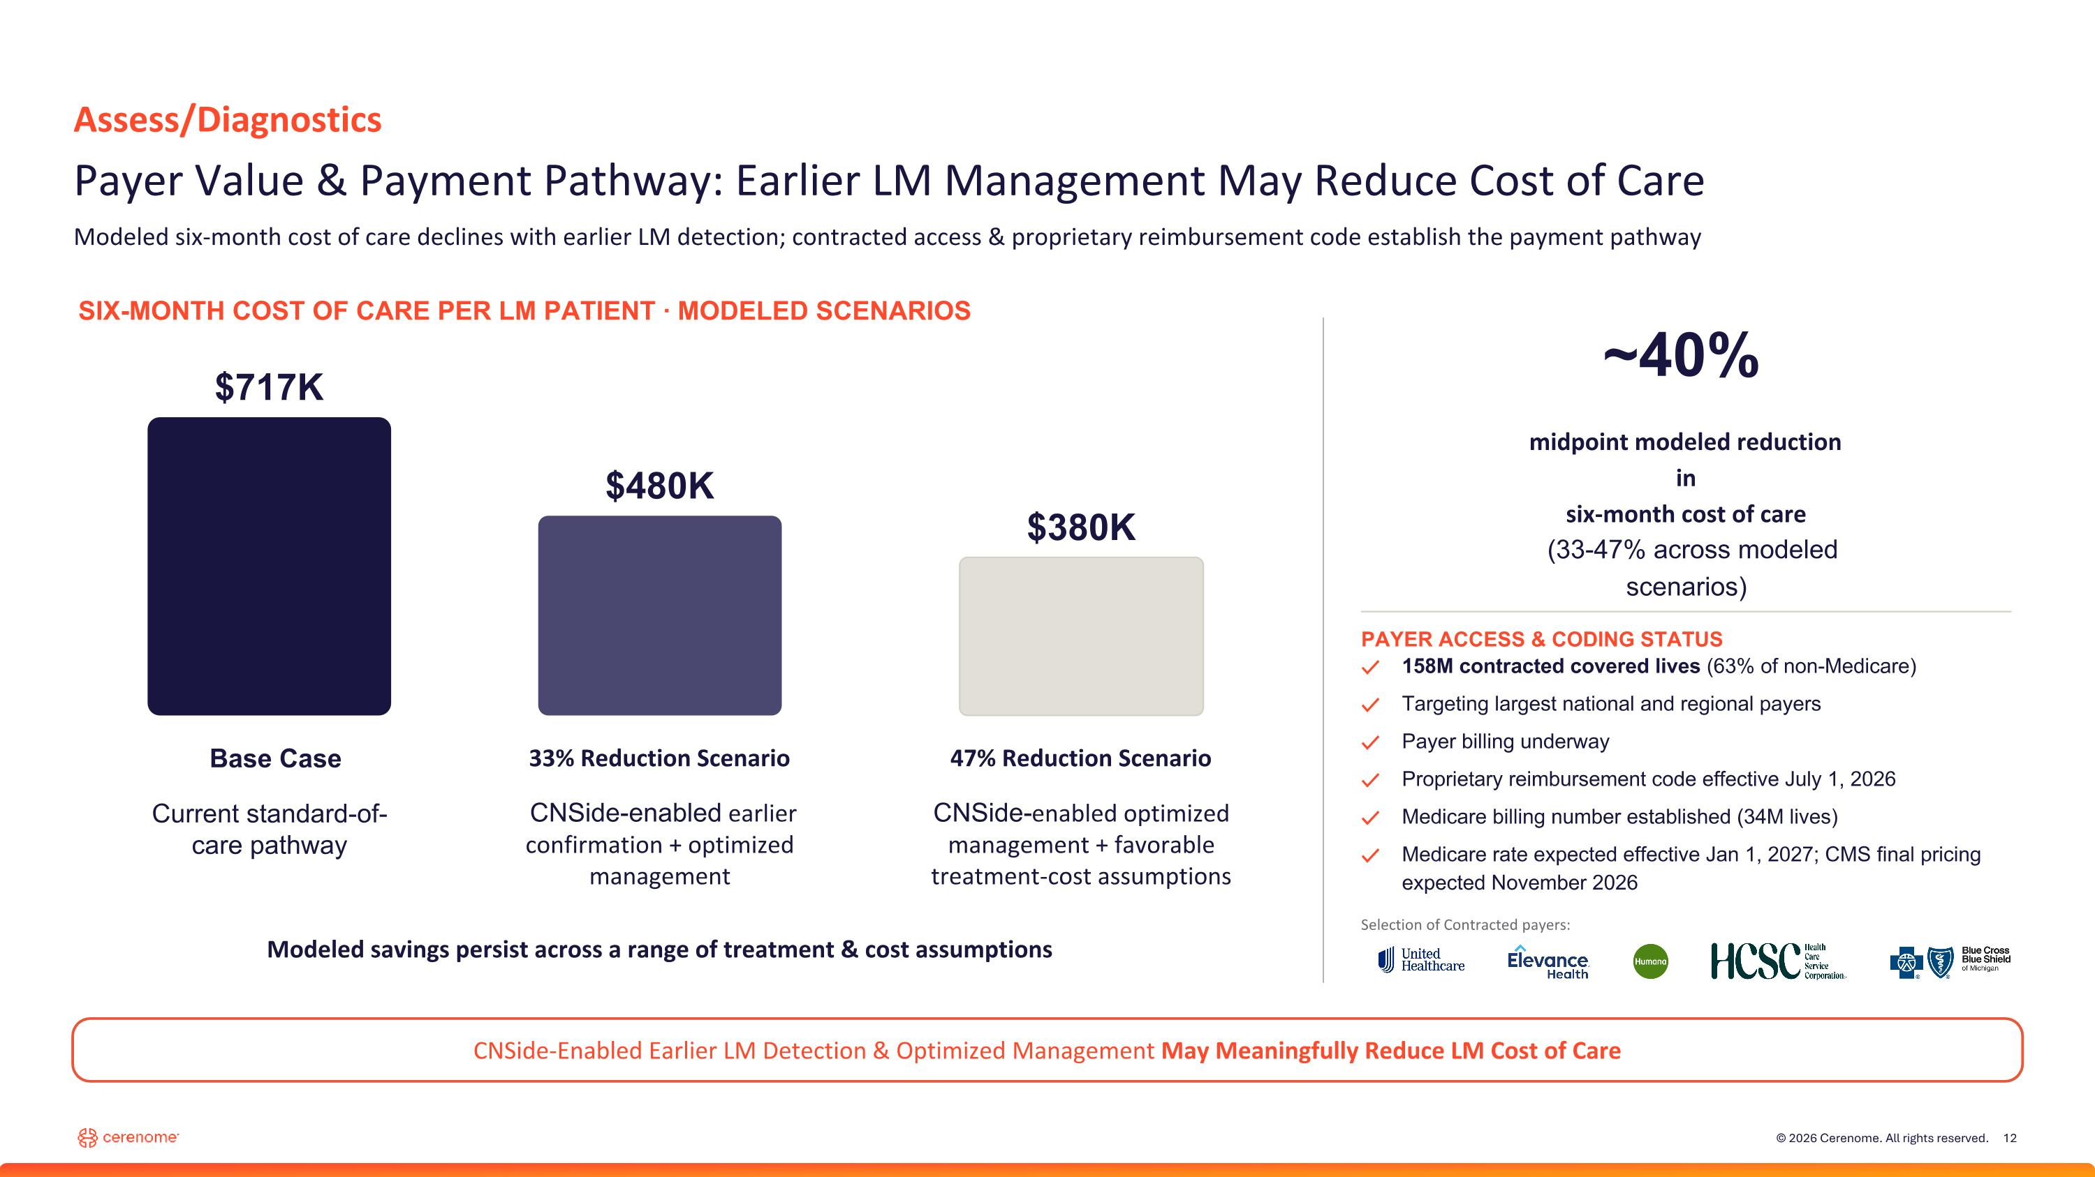
Assess/Diagnostics Payer Value & Payment Pathway: Earlier LM Management May Reduce Cost of Care Modeled six-month cost of care declines with earlier LM detection; contracted access & proprietary reimbursement code establish the payment pathway SIX-MONTH COST OF CARE PER LM PATIENT · MODELED SCENARIOS $717K Base Case Current standard-of-care pathway $480K 33% Reduction Scenario CNSide-enabled earlier confirmation + optimized management $380K 47% Reduction Scenario CNSide-enabled optimized management + favorable treatment-cost assumptions ~40% midpoint modeled reduction in six-month cost of care (33-47% across modeled scenarios) Modeled savings persist across a range of treatment & cost assumptions CNSide-Enabled Earlier LM Detection & Optimized Management May Meaningfully Reduce LM Cost of Care PAYER ACCESS & CODING STATUS ✓ 158M contracted covered lives (63% of non-Medicare) ✓ Targeting largest national and regional payers ✓ Payer billing underway ✓ Proprietary reimbursement code effective July 1, 2026 ✓ Medicare billing number established (34M lives) ✓ Medicare rate expected effective Jan 1, 2027; CMS final pricing expected November 2026 Selection of Contracted payers:

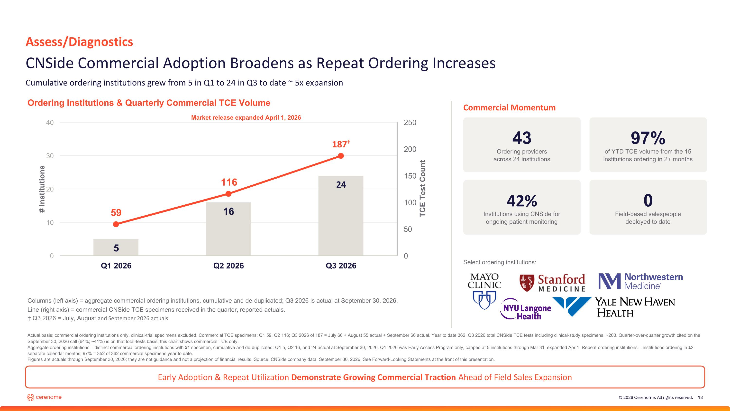
Early Adoption & Repeat Utilization Demonstrate Growing Commercial Traction Ahead of Field Sales Expansion Assess/Diagnostics CNSide Commercial Adoption Broadens as Repeat Ordering Increases Cumulative ordering institutions grew from 5 in Q1 to 24 in Q3 to date ~ 5x expansion Ordering Institutions & Quarterly Commercial TCE Volume Market release expanded April 1, 2026 Columns (left axis) = aggregate commercial ordering institutions, cumulative and de-duplicated; Q3 2026 is actual at September 30, 2026. Line (right axis) = commercial CNSide TCE specimens received in the quarter, reported actuals.  Q3 2026 = July, August and September 2026 actuals. Commercial Momentum 43 Ordering providers across 24 institutions 97% of YTD TCE volume from the 15 institutions ordering in 2+ months 42% Institutions using CNSide for ongoing patient monitoring 0 Field-based salespeople deployed to date Select ordering institutions: Actual basis; commercial ordering institutions only, clinical-trial specimens excluded. Commercial TCE specimens: Q1 59, Q2 116; Q3 2026 of 187 = July 66 + August 55 actual + September 66 actual. Year to date 362. Q3 2026 total CNSide TCE tests including clinical-study specimens: ~203. Quarter-over-quarter growth cited on the September 30, 2026 call (64%; ~41%) is on that total-tests basis; this chart shows commercial TCE only. Aggregate ordering institutions = distinct commercial ordering institutions with ≥1 specimen, cumulative and de-duplicated: Q1 5, Q2 16, and 24 actual at September 30, 2026. Q1 2026 was Early Access Program only, capped at 5 institutions through Mar 31, expanded Apr 1. Repeat-ordering institutions = institutions ordering in ≥2 separate calendar months; 97% = 352 of 362 commercial specimens year to date. Figures are actuals through September 30, 2026; they are not guidance and not a projection of financial results. Source: CNSide company data, September 30, 2026. See Forward-Looking Statements at the front of this presentation.

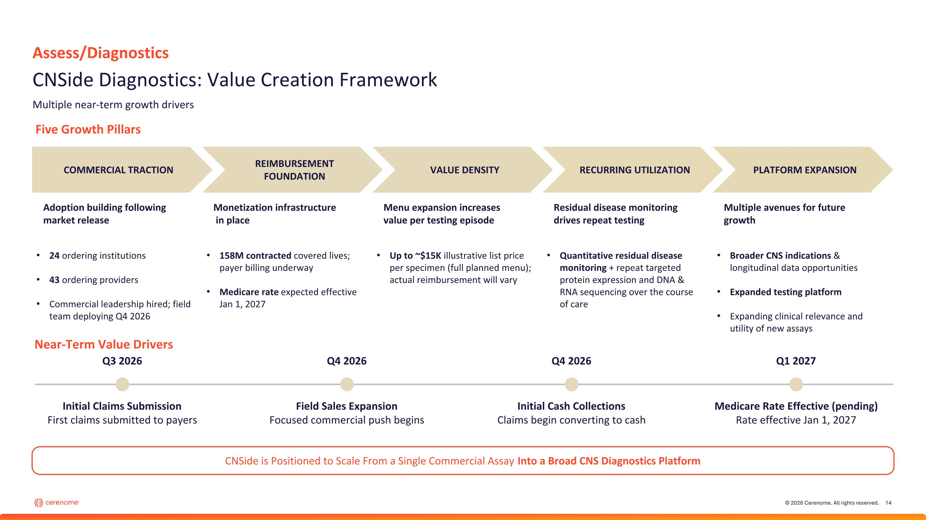
Assess/Diagnostics CNSide Diagnostics: Value Creation Framework Multiple near-term growth drivers COMMERCIAL TRACTION REIMBURSEMENT FOUNDATION VALUE DENSITY RECURRING UTILIZATION PLATFORM EXPANSION Adoption building following market release 24 ordering institutions 43 ordering providers Commercial leadership hired; field team deploying Q4 2026 CNSide is Positioned to Scale From a Single Commercial Assay Into a Broad CNS Diagnostics Platform Monetization infrastructure? in place 158M contracted covered lives; payer billing underway Medicare rate expected effective Jan 1, 2027 Menu expansion increases value per testing episode Up to ~$15K illustrative list price per specimen (full planned menu); actual reimbursement will vary Residual disease monitoring drives repeat testing Quantitative residual disease monitoring + repeat targeted protein expression and DNA & RNA sequencing over the course of care Multiple avenues for future growth Broader CNS indications & longitudinal data opportunities Expanded testing platform Expanding clinical relevance and utility of new assays Five Growth Pillars Near-Term Value Drivers Q3 2026 Q4 2026 Q4 2026 Q1 2027 Initial Claims Submission First claims submitted to payers Field Sales Expansion Focused commercial push begins Initial Cash Collections Claims begin converting to cash Medicare Rate Effective (pending) Rate effective Jan 1, 2027

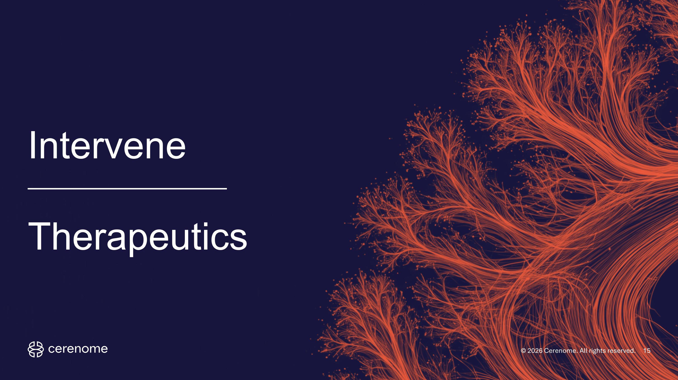
Intervene Therapeutics

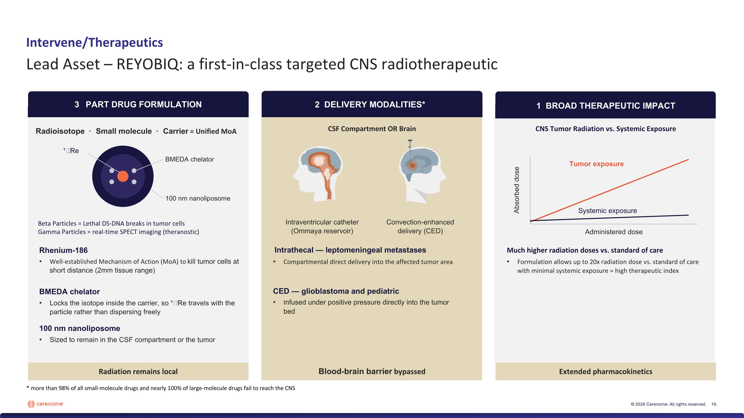
3 PART DRUG FORMULATION Radiation remains local 2 DELIVERY MODALITIES* Blood-brain barrier bypassed 1 BROAD THERAPEUTIC IMPACT Extended pharmacokinetics Radioisotope · Small molecule · Carrier = Unified MoA ¹⁸⁶Re BMEDA chelator 100 nm nanoliposome Beta Particles = Lethal DS-DNA breaks in tumor cells Gamma Particles = real-time SPECT imaging (theranostic) CSF Compartment OR Brain Intraventricular catheter (Ommaya reservoir) Convection-enhanced delivery (CED) CNS Tumor Radiation vs. Systemic Exposure Tumor exposure Systemic exposure Administered dose Absorbed dose Rhenium-186 Well-established Mechanism of Action (MoA) to kill tumor cells at short distance (2mm tissue range) BMEDA chelator Locks the isotope inside the carrier, so ¹⁸⁶Re travels with the particle rather than dispersing freely 100 nm nanoliposome Sized to remain in the CSF compartment or the tumor Intrathecal — leptomeningeal metastases Compartmental direct delivery into the affected tumor area CED — glioblastoma and pediatric Infused under positive pressure directly into the tumor bed Much higher radiation doses vs. standard of care Formulation allows up to 20x radiation dose vs. standard of care with minimal systemic exposure = high therapeutic index Intervene/Therapeutics Lead Asset – REYOBIQ: a first-in-class targeted CNS radiotherapeutic * more than 98% of all small-molecule drugs and nearly 100% of large-molecule drugs fail to reach the CNS

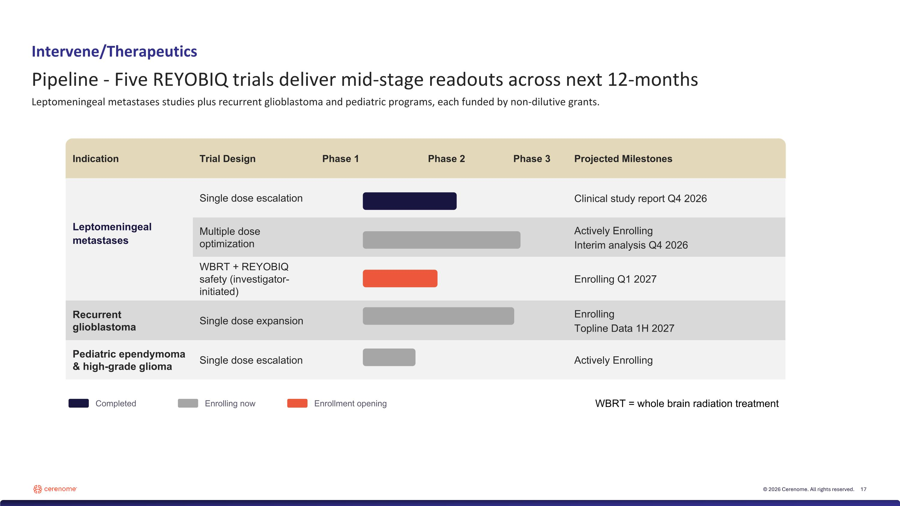
Completed Enrolling now Enrollment opening Intervene/Therapeutics Pipeline - Five REYOBIQ trials deliver mid-stage readouts across next 12-months Leptomeningeal metastases studies plus recurrent glioblastoma and pediatric programs, each funded by non-dilutive grants. Indication Trial Design Phase 1 Phase 2 Phase 3 Projected Milestones Leptomeningeal metastases Single dose escalation Clinical study report Q4 2026 Multiple dose optimization Actively Enrolling Interim analysis Q4 2026 WBRT + REYOBIQ safety (investigator-initiated) Enrolling Q1 2027 Recurrent glioblastoma Single dose expansion Enrolling Topline Data 1H 2027 Pediatric ependymoma ?& high-grade glioma Single dose escalation Actively Enrolling WBRT = whole brain radiation treatment

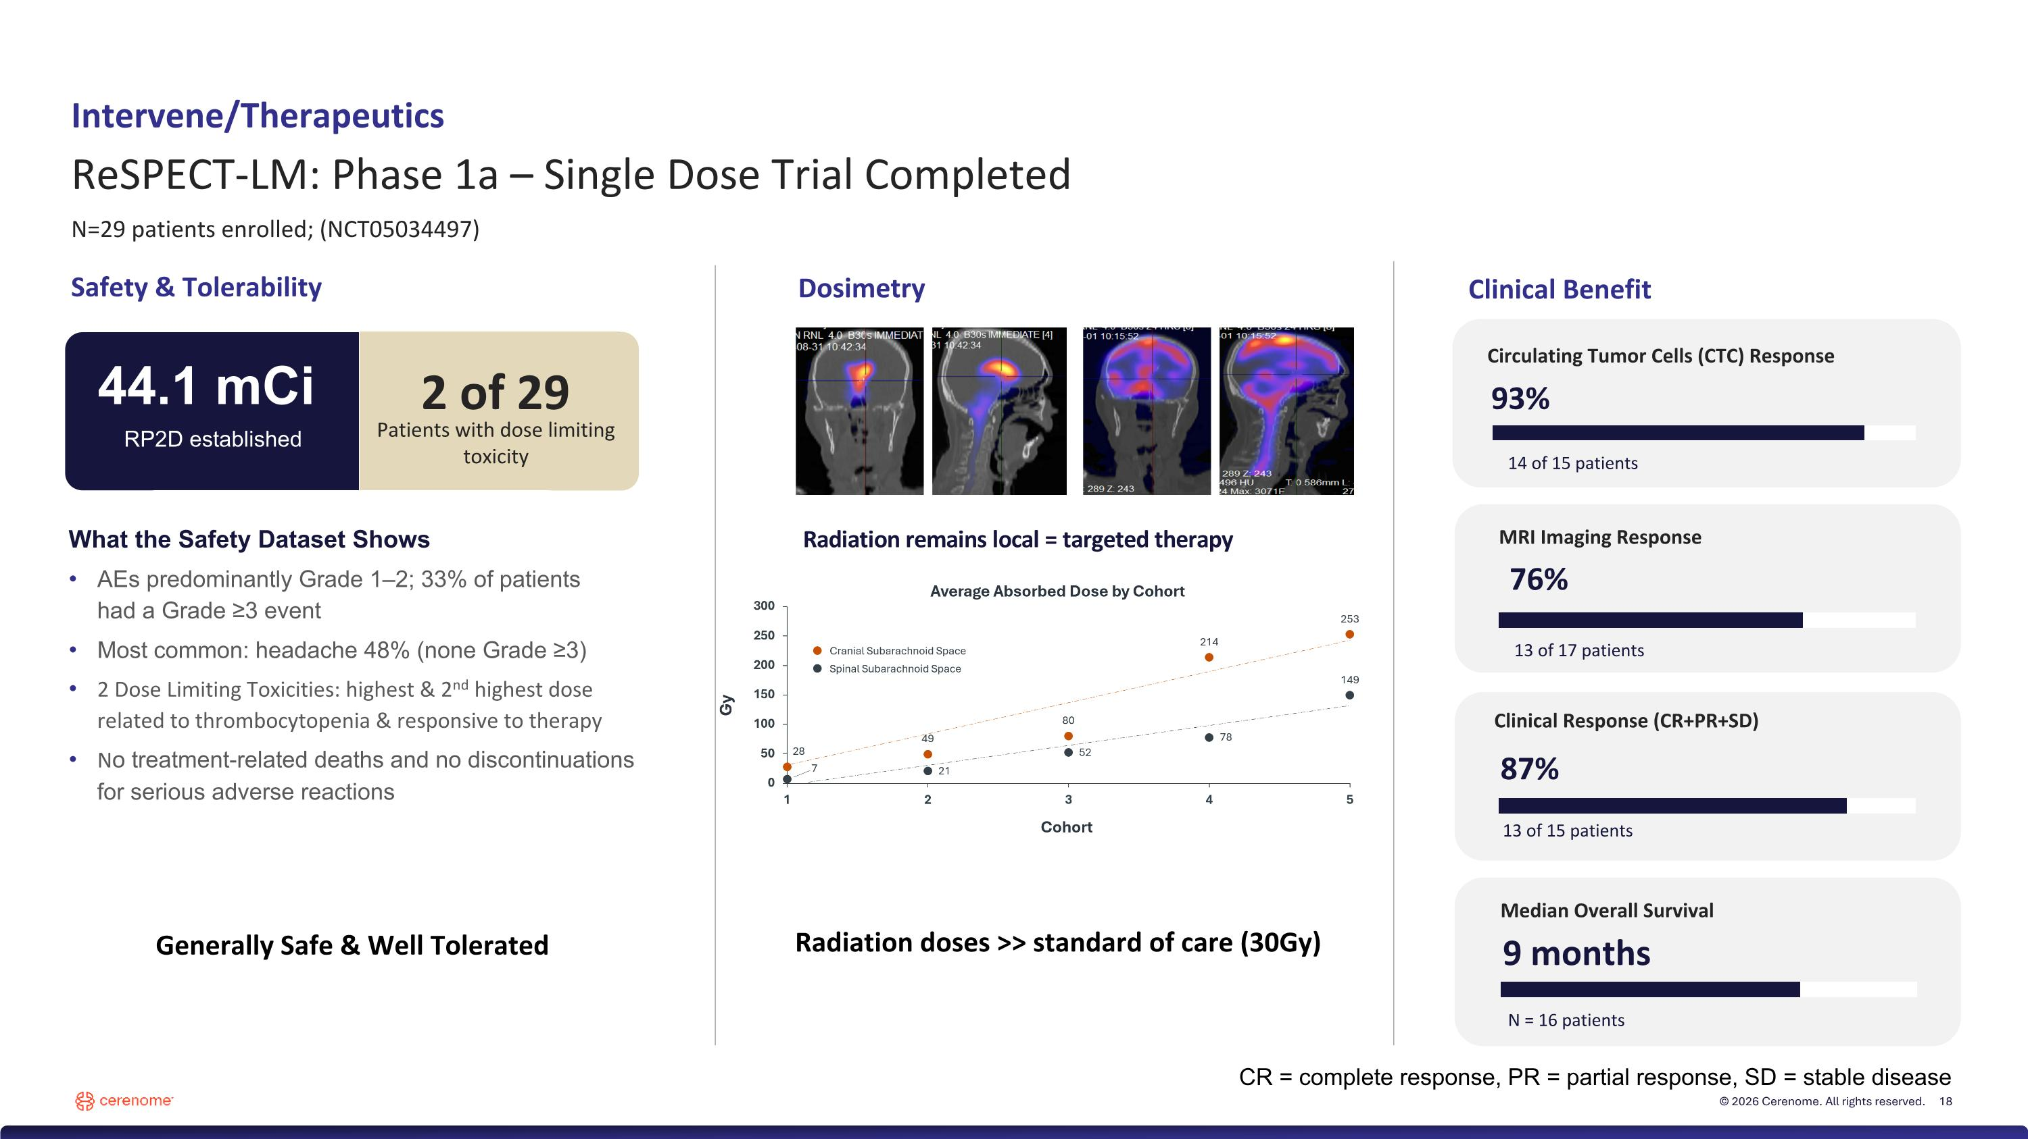
2 of 29 Intervene/Therapeutics ReSPECT-LM: Phase 1a – Single Dose Trial Completed N=29 patients enrolled; (NCT05034497) Safety & Tolerability What the Safety Dataset Shows AEs predominantly Grade 1–2; 33% of patients ?had a Grade ≥3 event Most common: headache 48% (none Grade ≥3) 2 Dose Limiting Toxicities: highest & 2nd highest dose related to thrombocytopenia & responsive to therapy No treatment-related deaths and no discontinuations for serious adverse reactions Dosimetry Radiation doses >> standard of care (30Gy) Radiation remains local = targeted therapy Generally Safe & Well Tolerated Patients with a DLT, both above RP2D Circulating Tumor Cells (CTC) Response 93% 14 of 15 patients MRI Imaging Response 76% 13 of 17 patients Clinical Response (CR+PR+SD) 87% 13 of 15 patients Median Overall Survival 9 months N = 16 patients Clinical Benefit 44.1 mCi RP2D established 2 of 29 Patients with dose limiting toxicity CR = complete response, PR = partial response, SD = stable disease

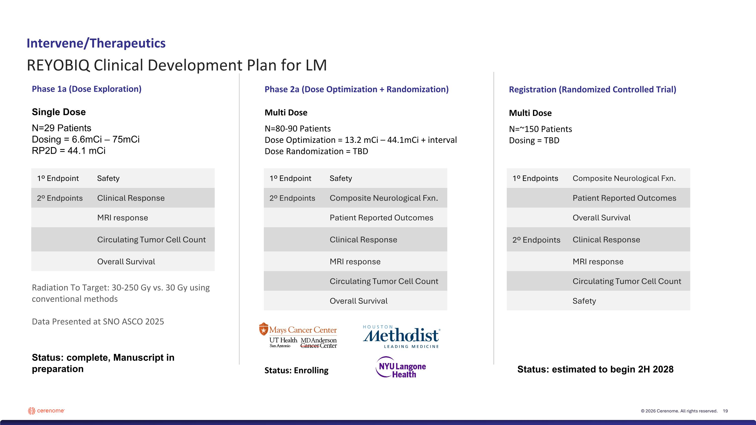
Intervene/Therapeutics Phase 2a (Dose Optimization + Randomization) Registration (Randomized Controlled Trial) Phase 1a (Dose Exploration) Single Dose N=29 Patients Dosing = 6.6mCi – 75mCi RP2D = 44.1 mCi Radiation To Target: 30-250 Gy vs. 30 Gy using conventional methods Data Presented at SNO ASCO 2025 Status: complete, Manuscript in preparation 1º Endpoint Safety 2º Endpoints Clinical Response MRI response Circulating Tumor Cell Count Overall Survival Multi Dose N=80-90 Patients Dose Optimization = 13.2 mCi – 44.1mCi + interval Dose Randomization = TBD Status: Enrolling Multi Dose N=~150 Patients Dosing = TBD 1º Endpoint Safety 2º Endpoints Composite Neurological Fxn. Patient Reported Outcomes Clinical Response MRI response Circulating Tumor Cell Count Overall Survival 1º Endpoints Composite Neurological Fxn. Patient Reported Outcomes Overall Survival 2º Endpoints Clinical Response MRI response Circulating Tumor Cell Count Safety Status: estimated to begin 2H 2028 REYOBIQ Clinical Development Plan for LM

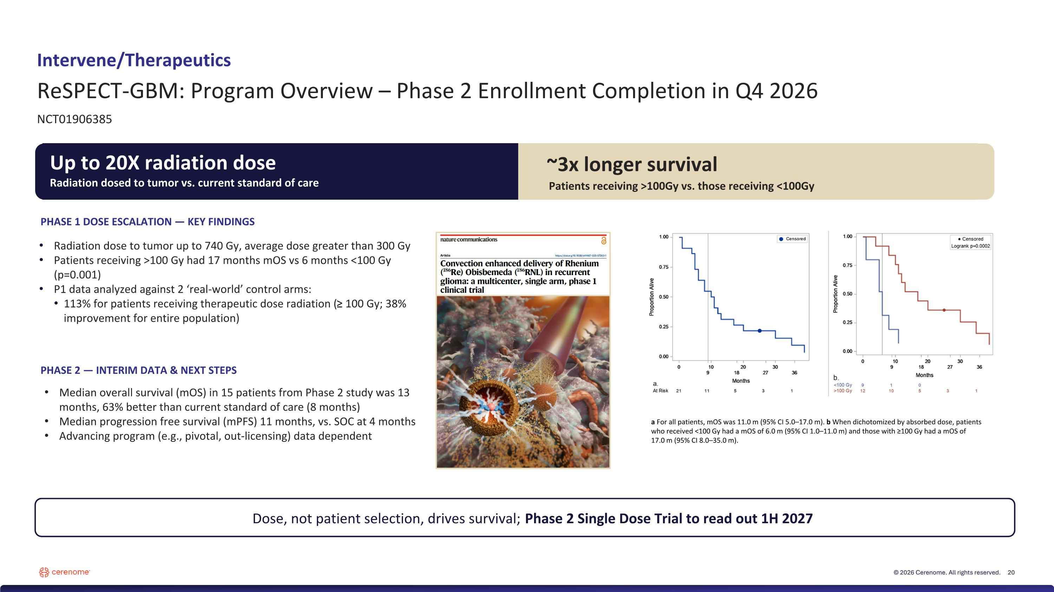
~3x longer survival Patients receiving >100Gy vs. those receiving <100Gy Dose, not patient selection, drives survival; Phase 2 Single Dose Trial to read out 1H 2027 PHASE 2 — INTERIM DATA & NEXT STEPS Radiation dose to tumor up to 740 Gy, average dose greater than 300 Gy Patients receiving >100 Gy had 17 months mOS vs 6 months <100 Gy (p=0.001) P1 data analyzed against 2 ‘real-world’ control arms: 113% for patients receiving therapeutic dose radiation (≥ 100 Gy; 38% improvement for entire population) Median overall survival (mOS) in 15 patients from Phase 2 study was 13 months, 63% better than current standard of care (8 months) Median progression free survival (mPFS) 11 months, vs. SOC at 4 months Advancing program (e.g., pivotal, out-licensing) data dependent PHASE 1 DOSE ESCALATION — KEY FINDINGS Intervene/Therapeutics ReSPECT-GBM: Program Overview – Phase 2 Enrollment Completion in Q4 2026 NCT01906385 a For all patients, mOS was 11.0 m (95% CI 5.0–17.0 m). b When dichotomized by absorbed dose, patients who received <100 Gy had a mOS of 6.0 m (95% CI 1.0–11.0 m) and those with ≥100 Gy had a mOS of 17.0 m (95% CI 8.0–35.0 m). Up to 20X radiation dose Radiation dosed to tumor vs. current standard of care

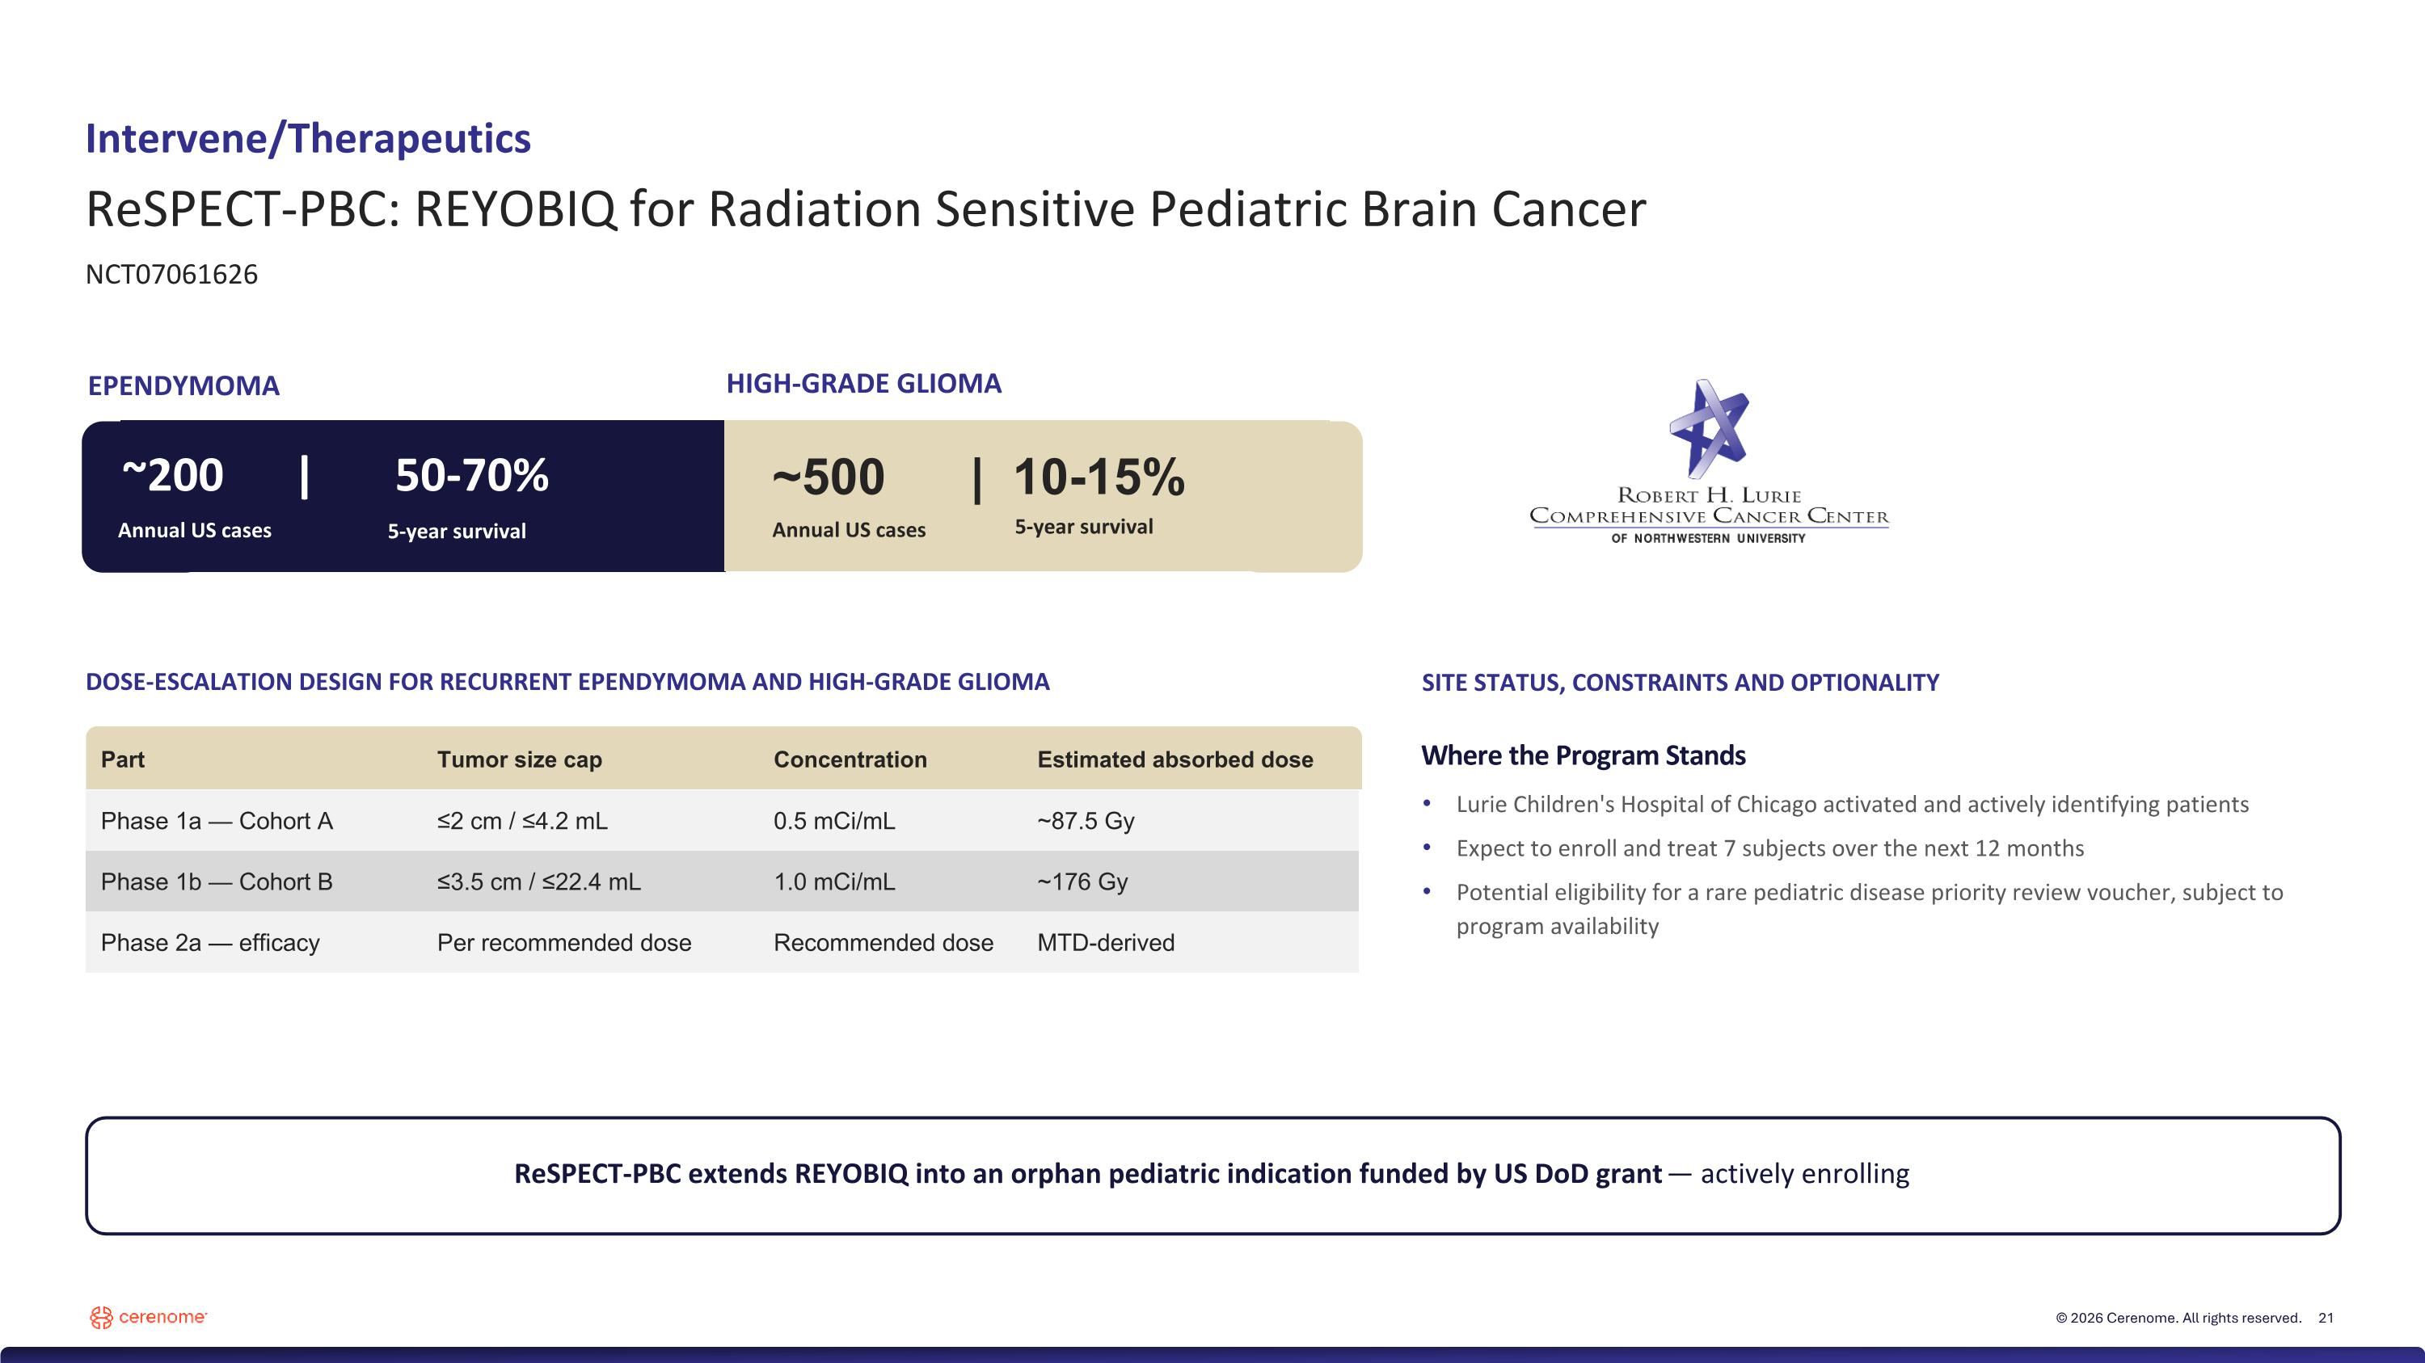
Part Tumor size cap Concentration Estimated absorbed dose Phase 1a — Cohort A ≤2 cm / ≤4.2 mL 0.5 mCi/mL ~87.5 Gy Phase 1b — Cohort B ≤3.5 cm / ≤22.4 mL 1.0 mCi/mL ~176 Gy Phase 2a — efficacy Per recommended dose Recommended dose MTD-derived Intervene/Therapeutics ReSPECT-PBC: REYOBIQ for Radiation Sensitive Pediatric Brain Cancer NCT07061626 ~500 | 10-15% RP2D and dosing interval locked ReSPECT-PBC extends REYOBIQ into an orphan pediatric indication funded by US DoD grant — actively enrolling DOSE-ESCALATION DESIGN FOR RECURRENT EPENDYMOMA AND HIGH-GRADE GLIOMA SITE STATUS, CONSTRAINTS AND OPTIONALITY Where the Program Stands Lurie Children's Hospital of Chicago activated and actively identifying patients Expect to enroll and treat 7 subjects over the next 12 months Potential eligibility for a rare pediatric disease priority review voucher, subject to program availability EPENDYMOMA HIGH-GRADE GLIOMA Annual US cases 5-year survival ~200 | 50-70% Annual US cases 5-year survival


Learn Data Analytics

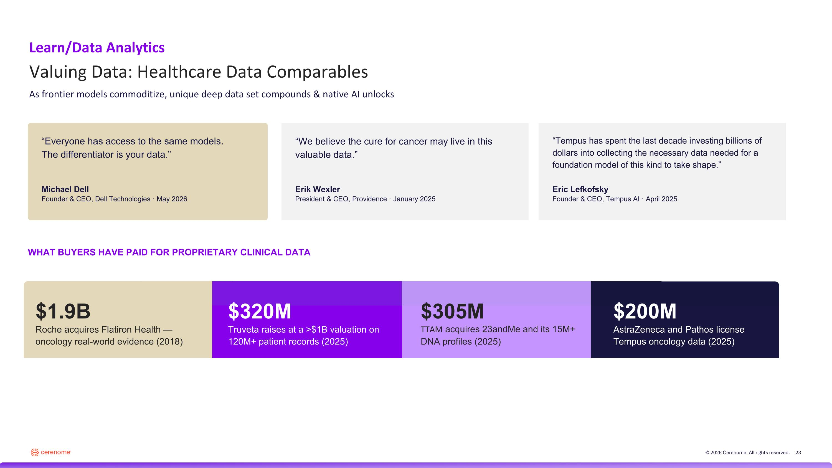
“Everyone has access to the same models. ?The differentiator is your data.” Michael Dell Founder & CEO, Dell Technologies · May 2026 “We believe the cure for cancer may live in this valuable data.” Erik Wexler President & CEO, Providence · January 2025 “Tempus has spent the last decade investing billions of dollars into collecting the necessary data needed for a foundation model of this kind to take shape.” Eric Lefkofsky Founder & CEO, Tempus AI · April 2025 WHAT BUYERS HAVE PAID FOR PROPRIETARY CLINICAL DATA Learn/Data Analytics Valuing Data: Healthcare Data Comparables As frontier models commoditize, unique deep data set compounds & native AI unlocks $1.9B Roche acquires Flatiron Health — oncology real-world evidence (2018) $320M Truveta raises at a >$1B valuation on 120M+ patient records (2025) $305M TTAM acquires 23andMe and its 15M+ DNA profiles (2025) $200M AstraZeneca and Pathos license Tempus oncology data (2025)

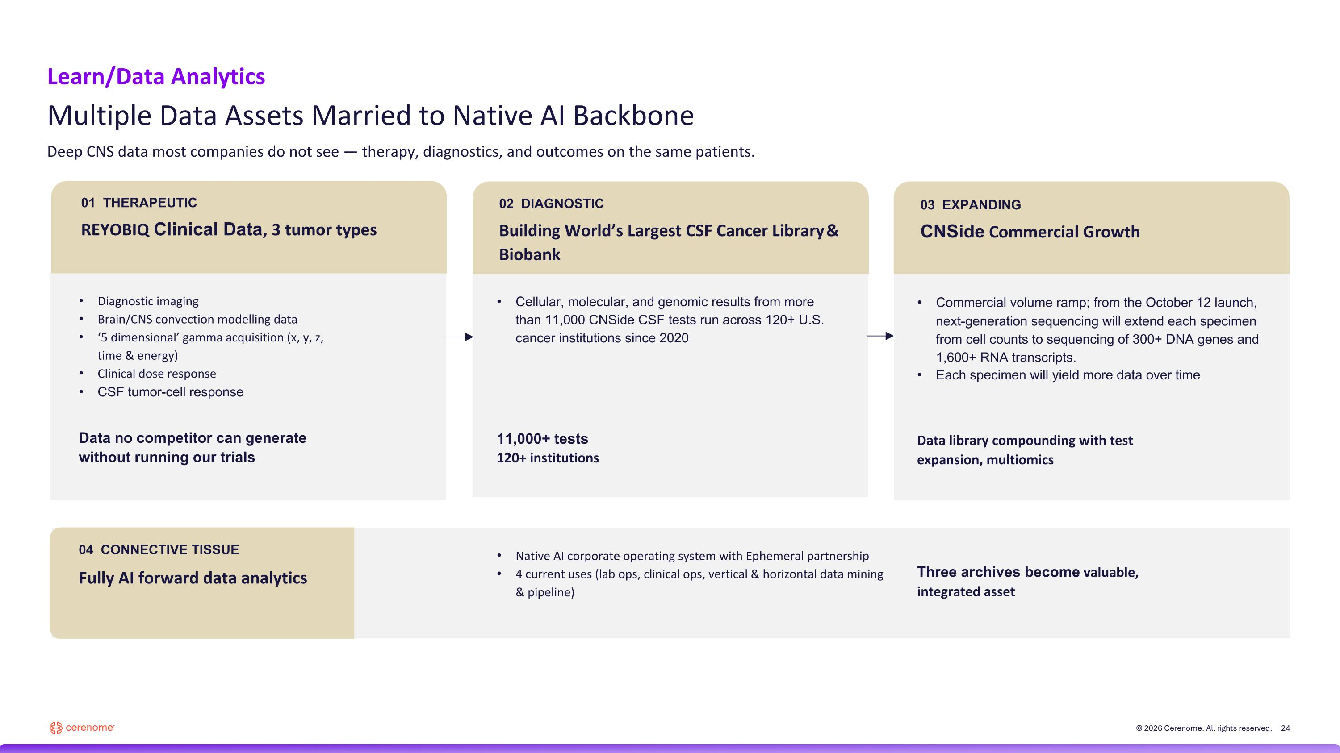
01 THERAPEUTIC REYOBIQ Clinical Data, 3 tumor types Diagnostic imaging Brain/CNS convection modelling data ‘5 dimensional’ gamma acquisition (x, y, z, time & energy) Clinical dose response CSF tumor-cell response Data no competitor can generate
without running our trials 02 DIAGNOSTIC Building World’s Largest CSF Cancer Library & Biobank Cellular, molecular, and genomic results from more than 11,000 CNSide CSF tests run across 120+ U.S. cancer institutions since 2020 11,000+ tests
120+ institutions 03 EXPANDING CNSide Commercial Growth Commercial volume ramp; from the October 12 launch, next-generation sequencing will extend each specimen from cell counts to sequencing of 300+ DNA genes and 1,600+ RNA transcripts. Each specimen will yield more data over time Data library compounding with test expansion, multiomics 04 CONNECTIVE TISSUE Fully AI forward data analytics Native AI corporate operating system with Ephemeral partnership 4 current uses (lab ops, clinical ops, vertical & horizontal data mining & pipeline) Three archives become valuable, integrated asset Learn/Data Analytics Multiple Data Assets Married to Native AI Backbone Deep CNS data most companies do not see — therapy, diagnostics, and outcomes on the same patients.

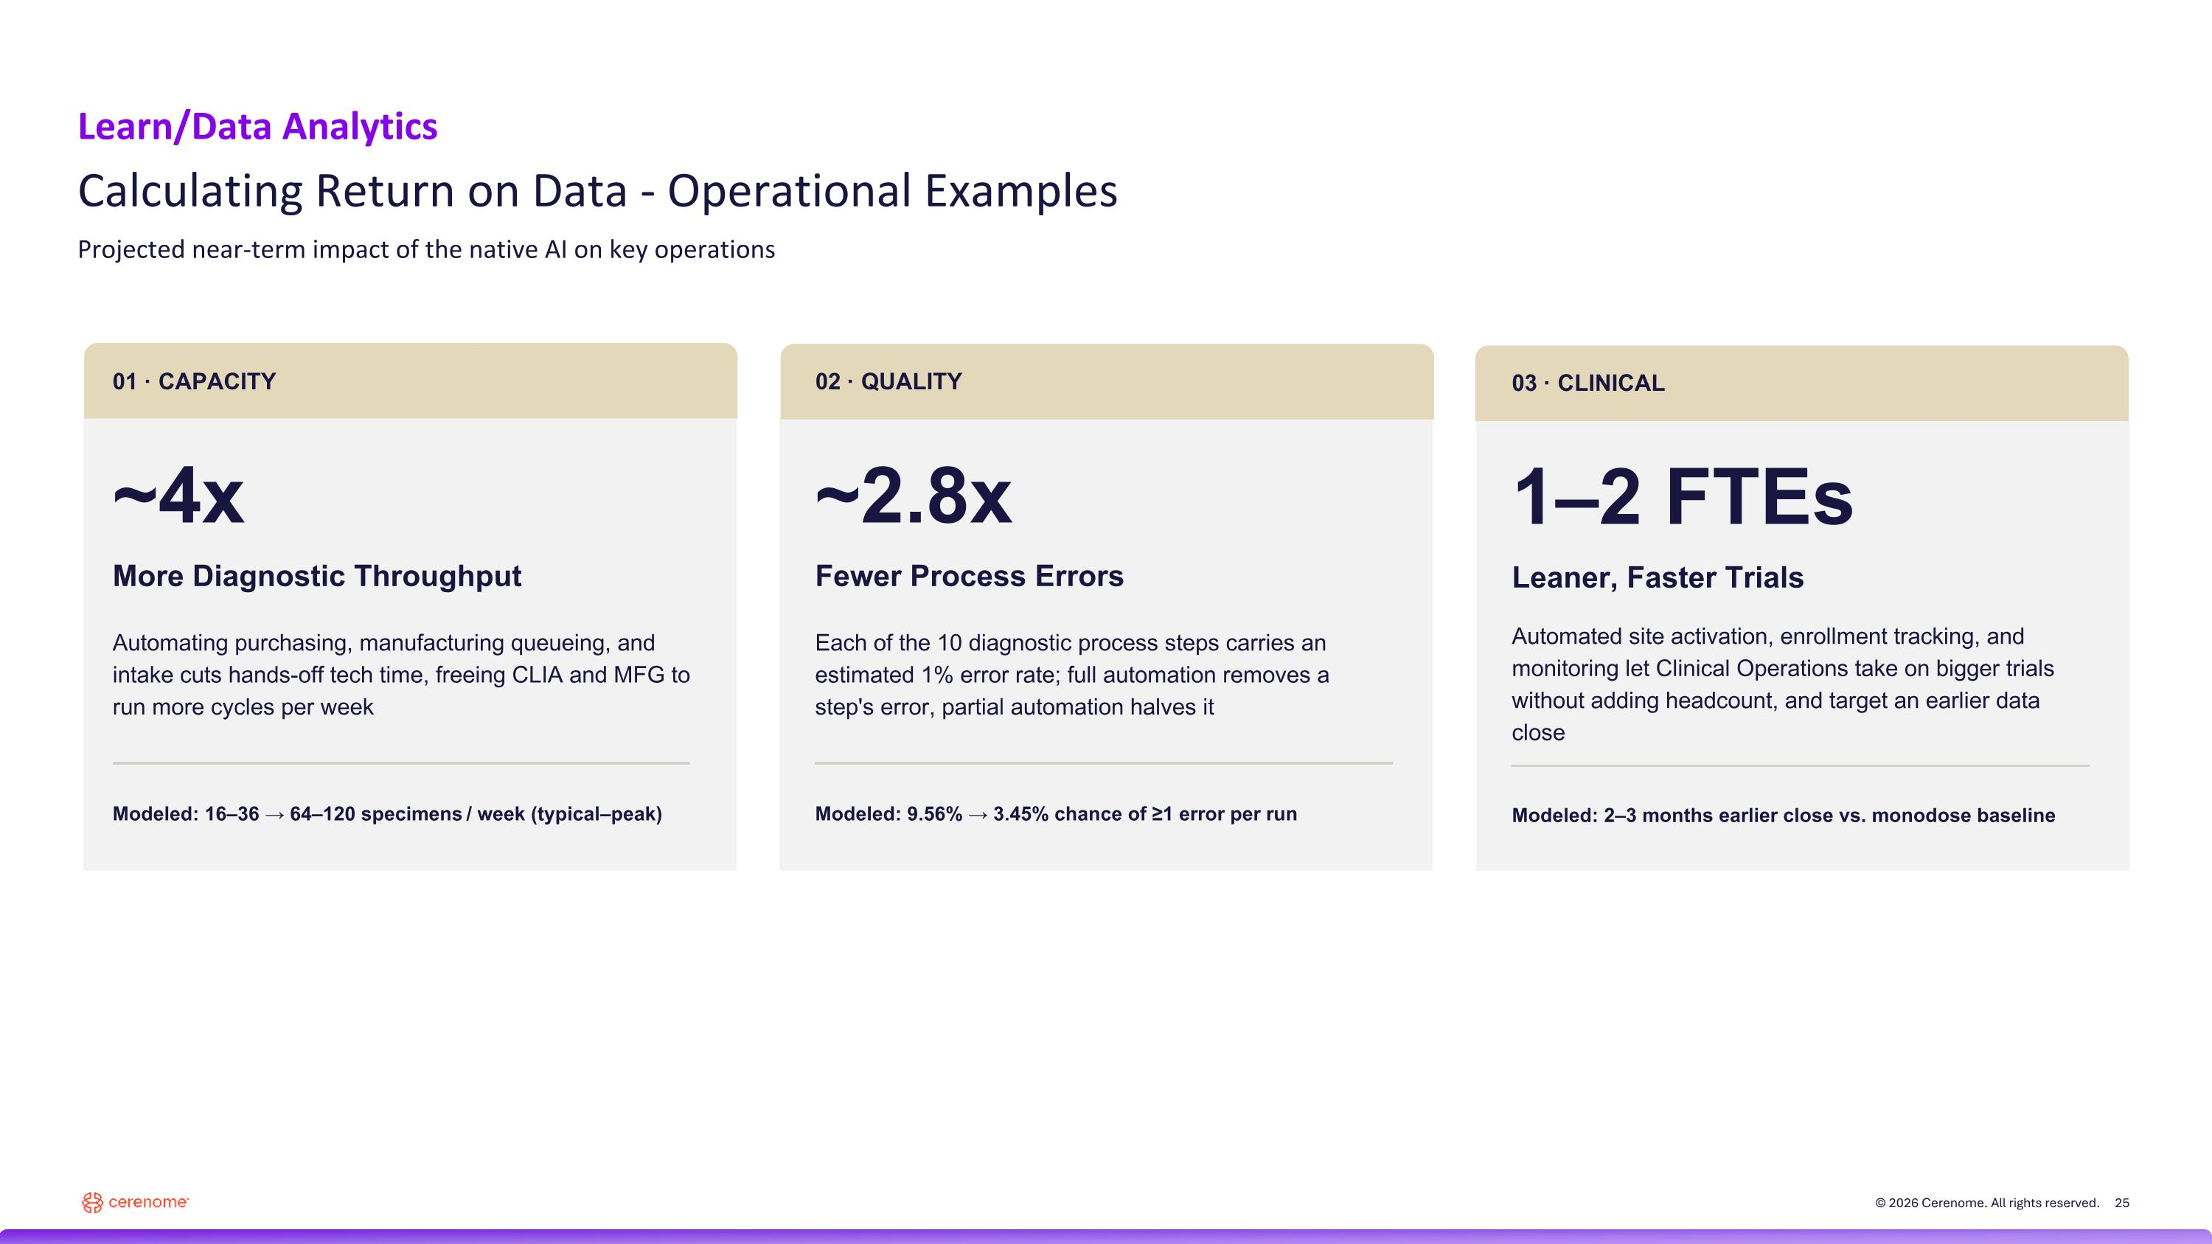
Learn/Data Analytics Calculating Return on Data - Operational Examples Projected near-term impact of the native AI on key operations 01 · CAPACITY 02 · QUALITY 03 · CLINICAL ~4x More Diagnostic Throughput Automating purchasing, manufacturing queueing, and intake cuts hands-off tech time, freeing CLIA and MFG to run more cycles per week Modeled: 16–36 → 64–120 specimens / week (typical–peak) ~2.8x Fewer Process Errors Each of the 10 diagnostic process steps carries an estimated 1% error rate; full automation removes a step's error, partial automation halves it Modeled: 9.56% → 3.45% chance of ≥1 error per run 1–2 FTEs Leaner, Faster Trials Automated site activation, enrollment tracking, and monitoring let Clinical Operations take on bigger trials without adding headcount, and target an earlier data close Modeled: 2–3 months earlier close vs. monodose baseline

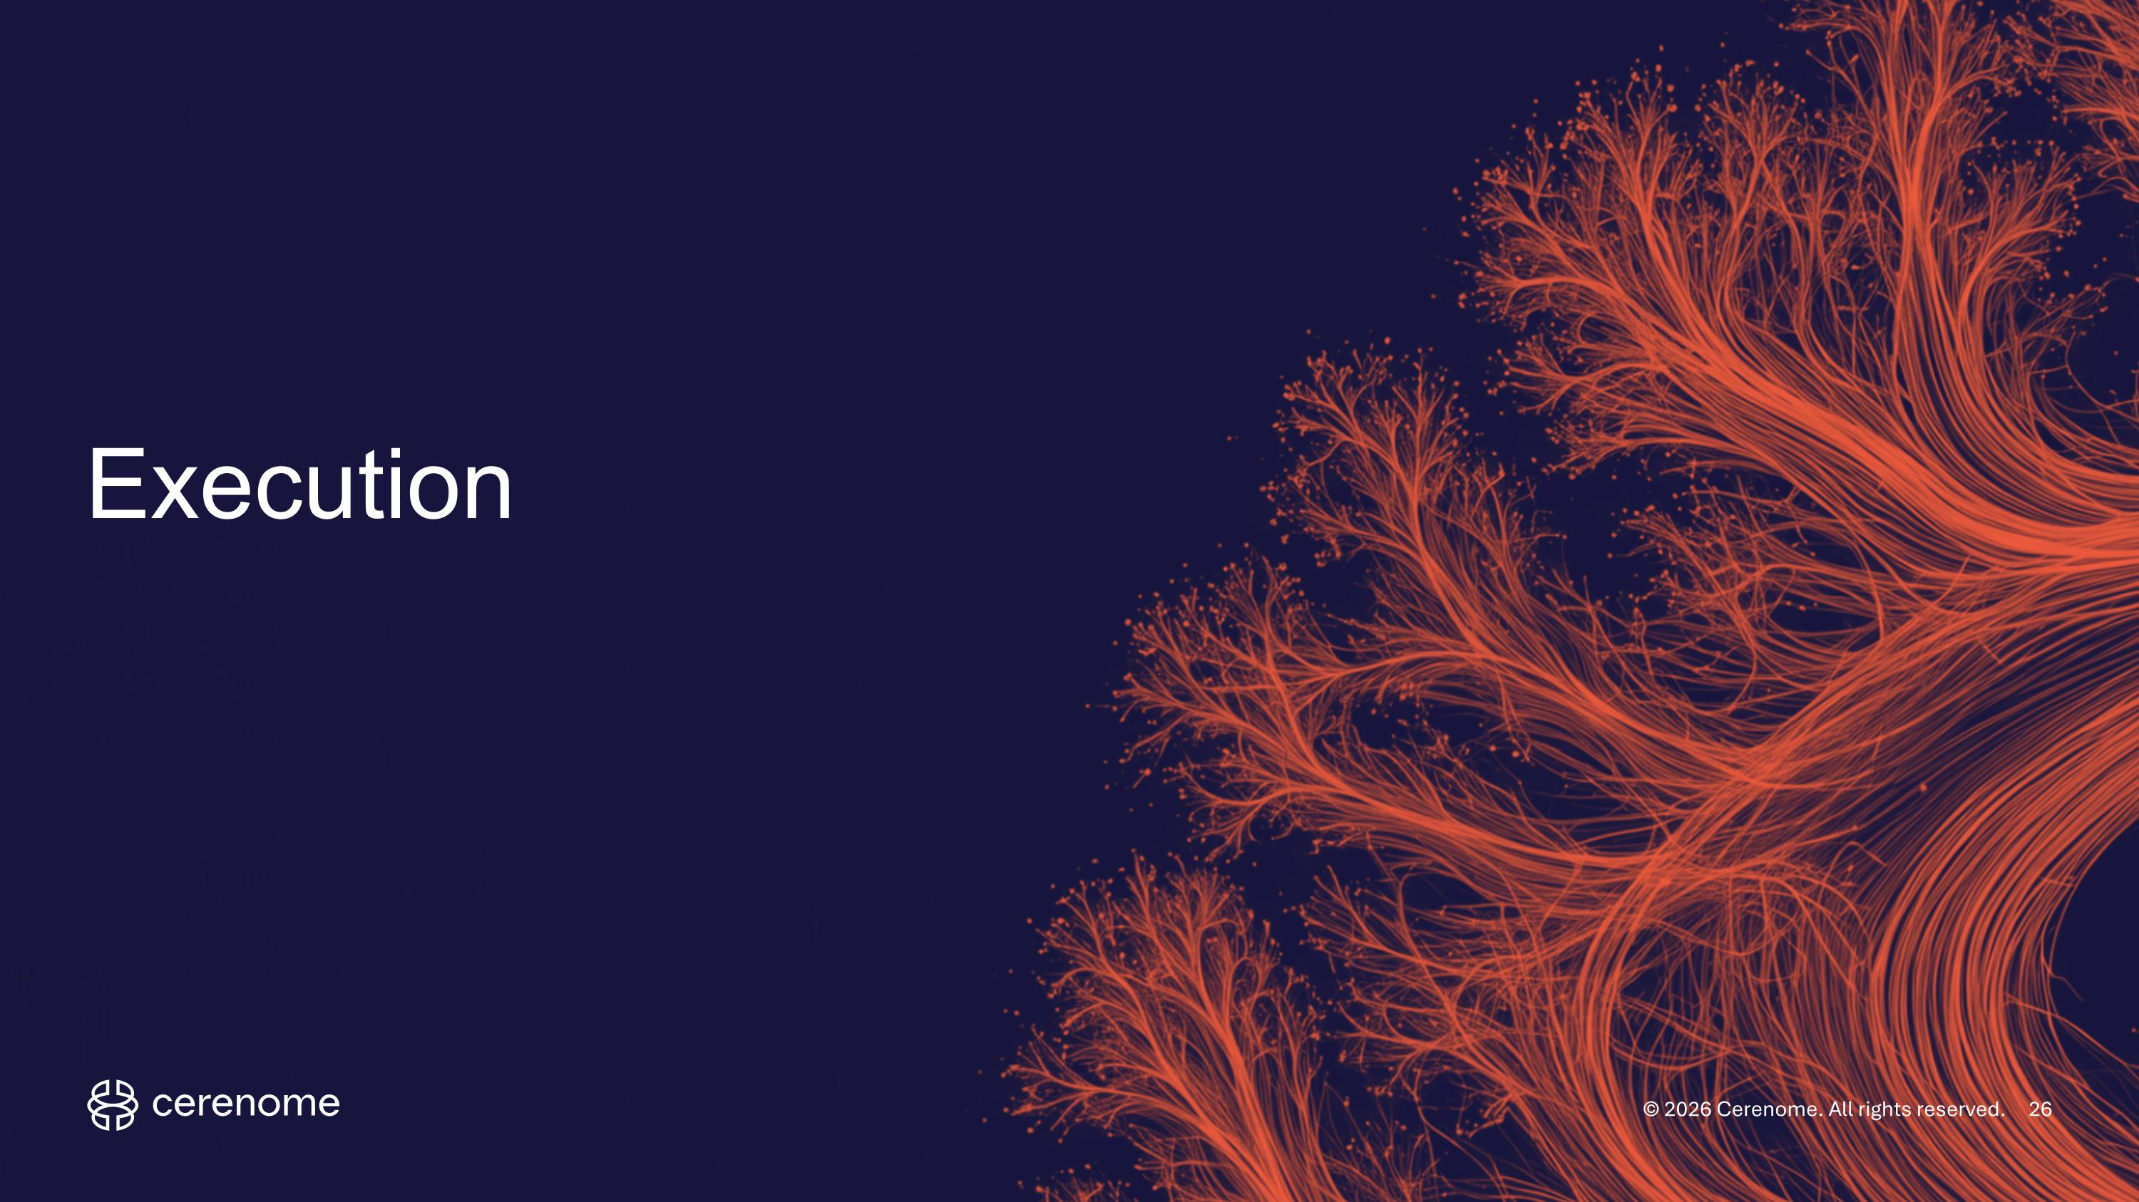
Execution

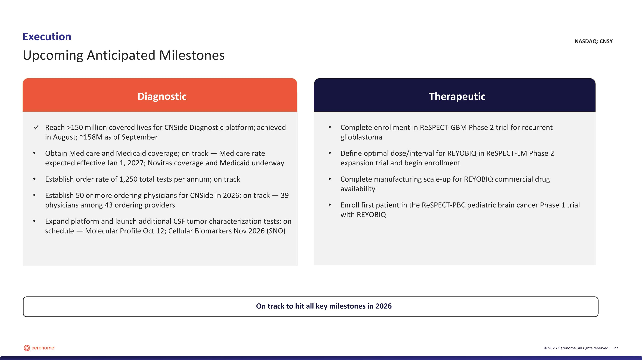
Diagnostic Therapeutic Reach >150 million covered lives for CNSide Diagnostic platform;​ achieved in August; ~158M as of September Obtain Medicare and Medicaid coverage; on track — Medicare rate expected effective Jan 1, 2027; Novitas coverage and Medicaid underway Establish order rate of 1,250 total tests per annum​; on track Establish 50 or more ordering physicians for CNSide in 2026​; on track — 39 physicians among 43 ordering providers Expand platform and launch additional CSF tumor characterization tests; on schedule — Molecular Profile Oct 12; Cellular Biomarkers Nov 2026 (SNO) Complete enrollment in ReSPECT-GBM Phase 2 trial for recurrent glioblastoma Define optimal dose/interval for REYOBIQ in ReSPECT-LM Phase 2 expansion trial and begin enrollment​ Complete manufacturing scale-up for REYOBIQ commercial drug availability​ Enroll first patient in the ReSPECT-PBC pediatric brain cancer Phase 1 trial with REYOBIQ Execution Upcoming Anticipated Milestones On track to hit all key milestones in 2026 NASDAQ: CNSY


Think it solvable. Contact us at investor@cerenome.com

